Tour ID: 260619  
Tour Name: 3 Days Private Super Jeep Tour | Landmannalaugar, Thorsmork and South Coast

Tour destinations: ['Reykjavik', 'Landmannalaugar', 'Thorsmork', 'Skogafoss', 'Seljaland', 'Reynisfjara']

Tour destinations images:

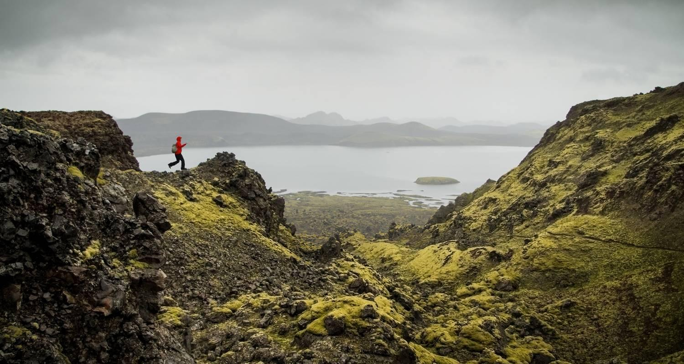

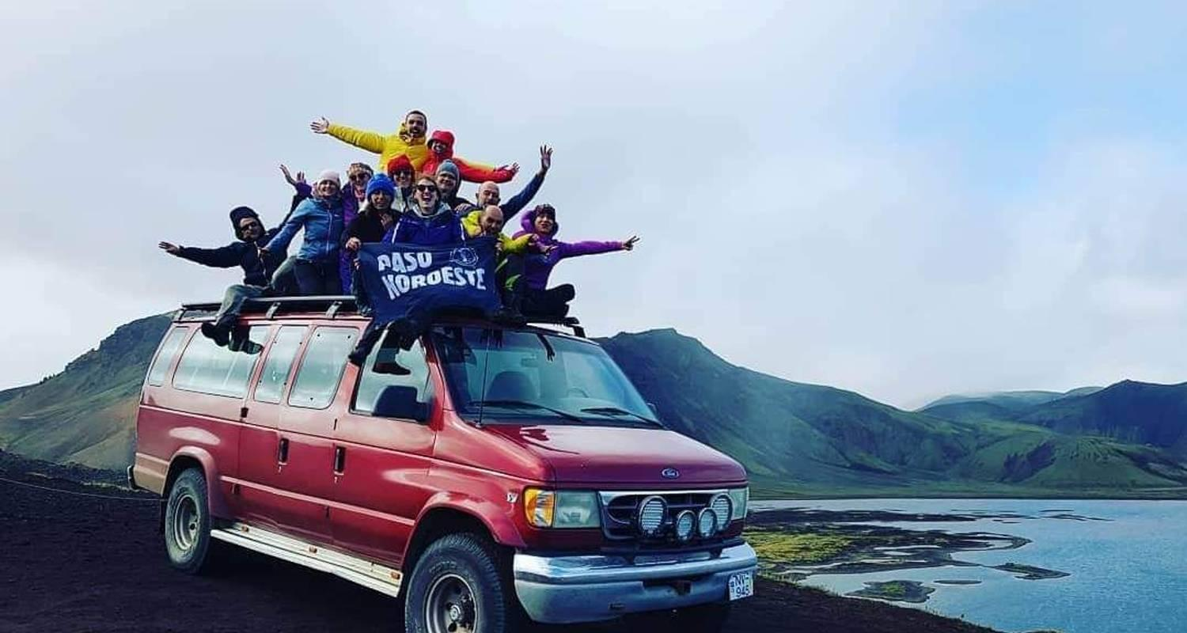

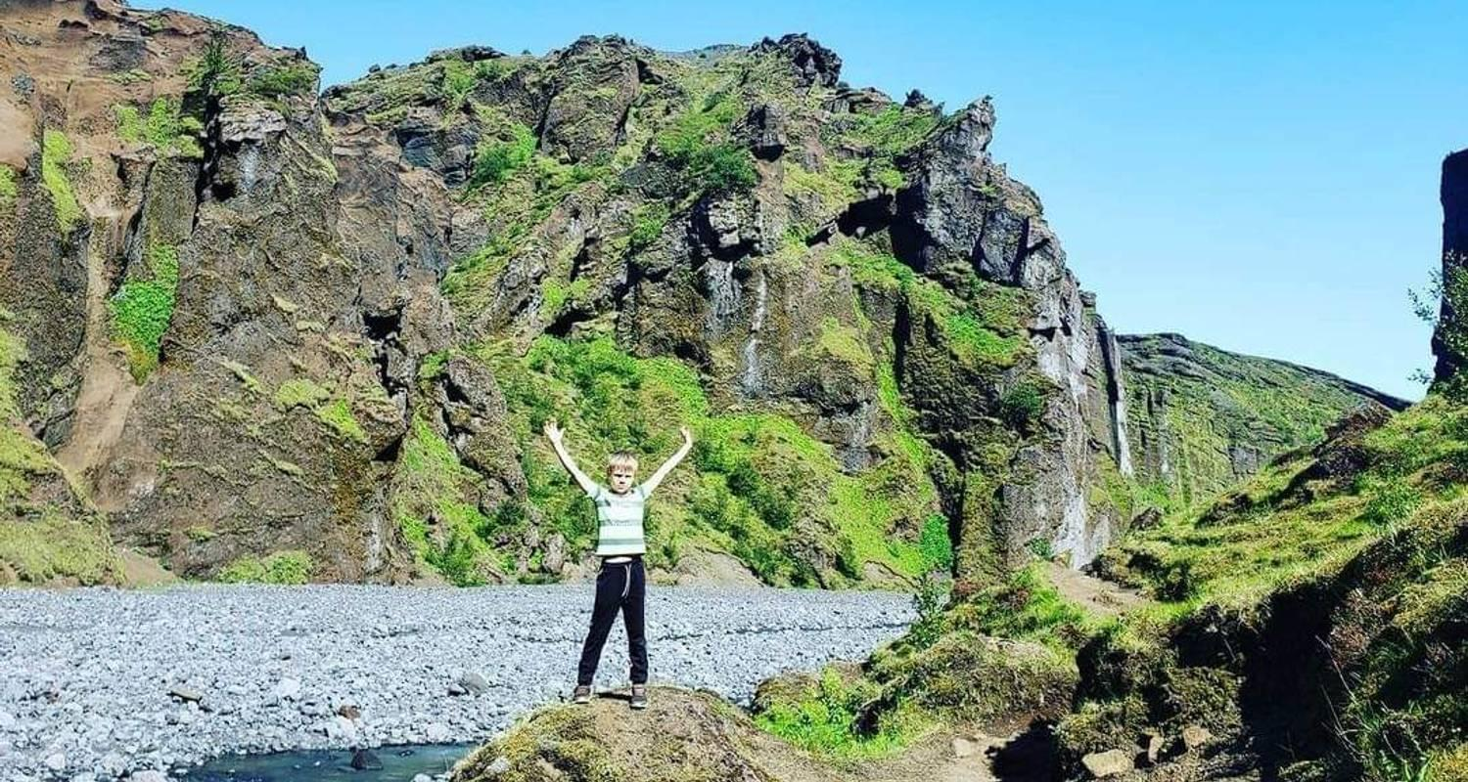

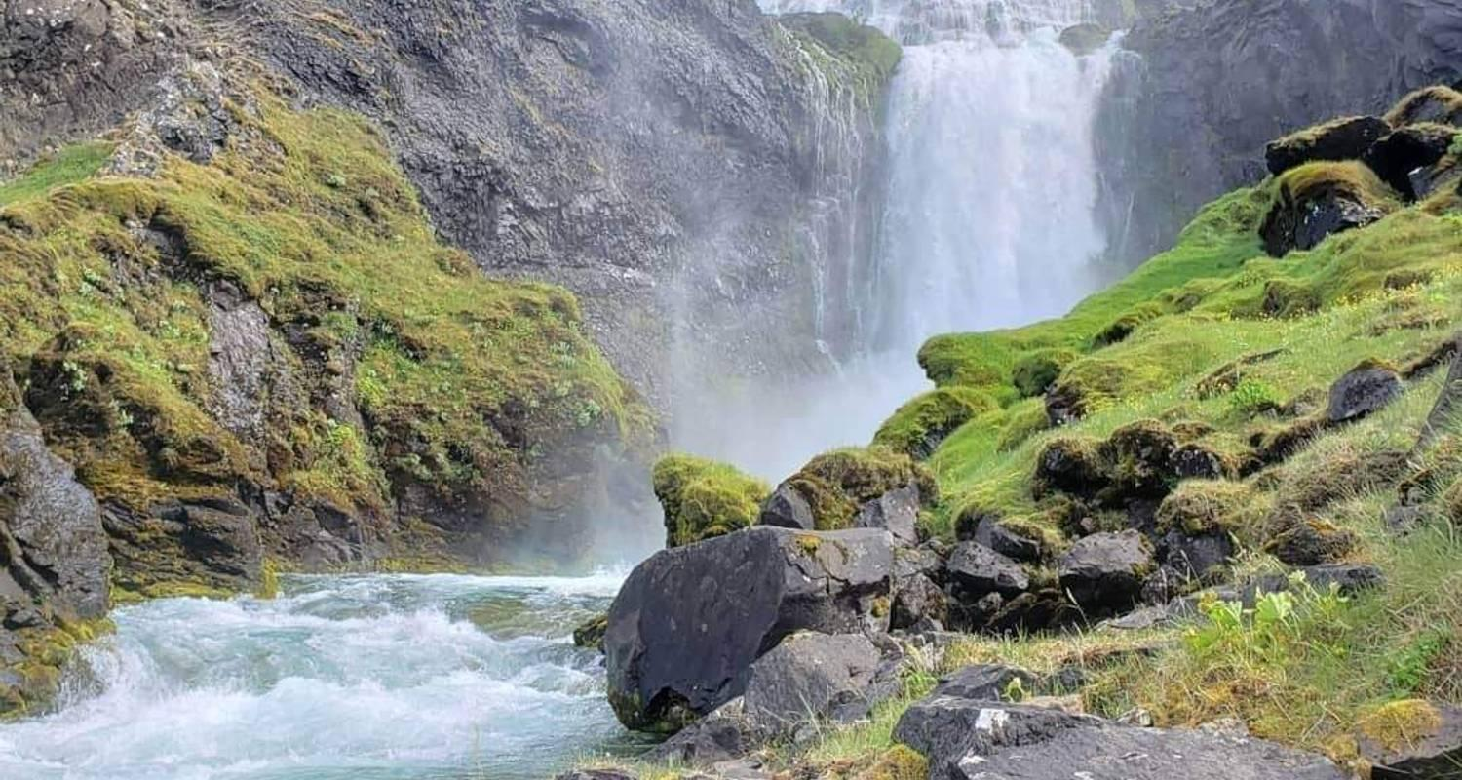

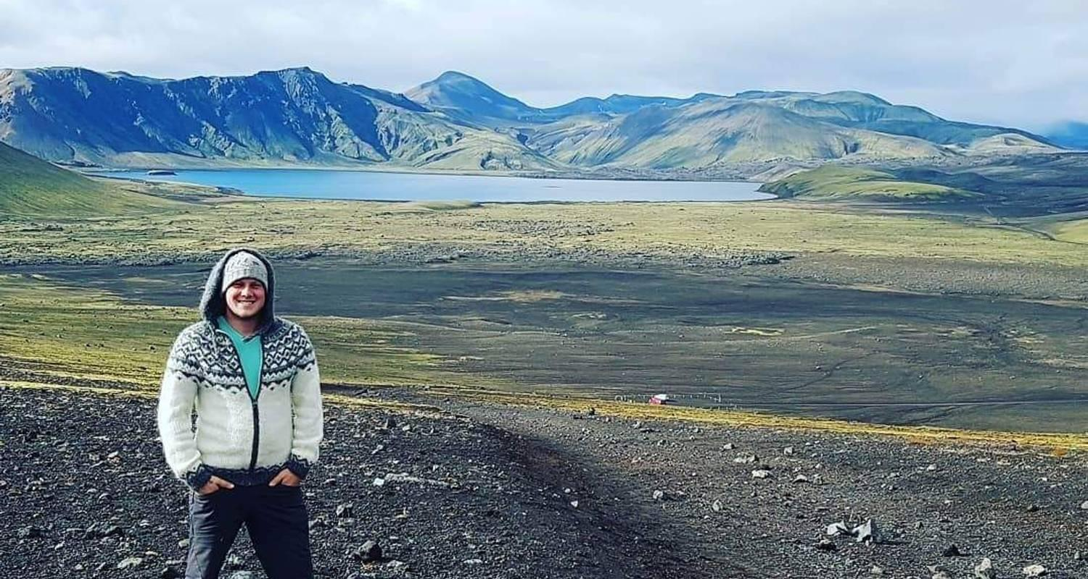

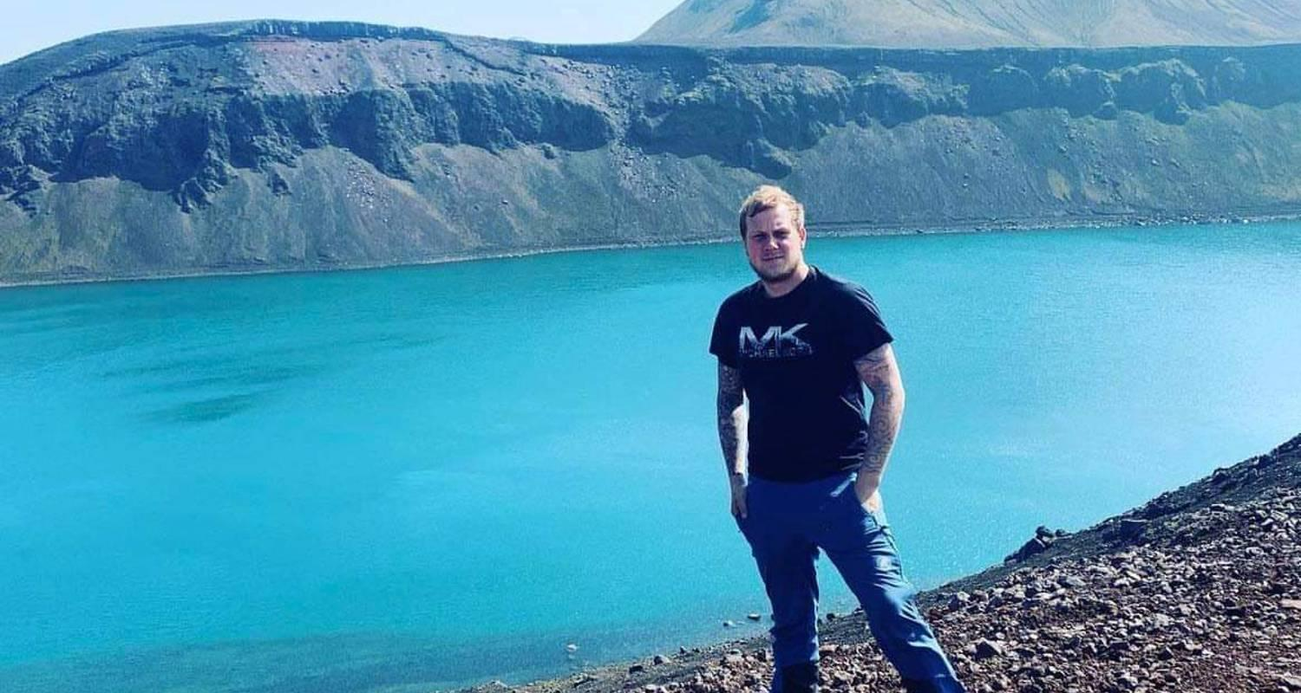

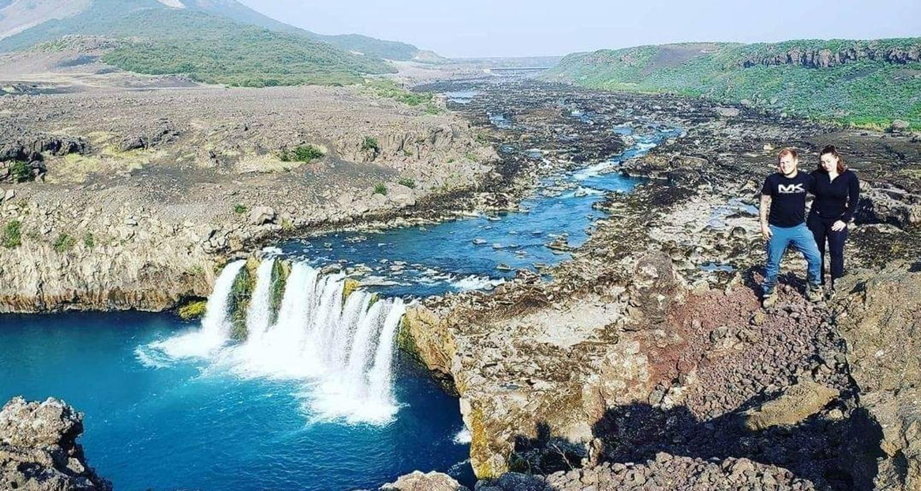

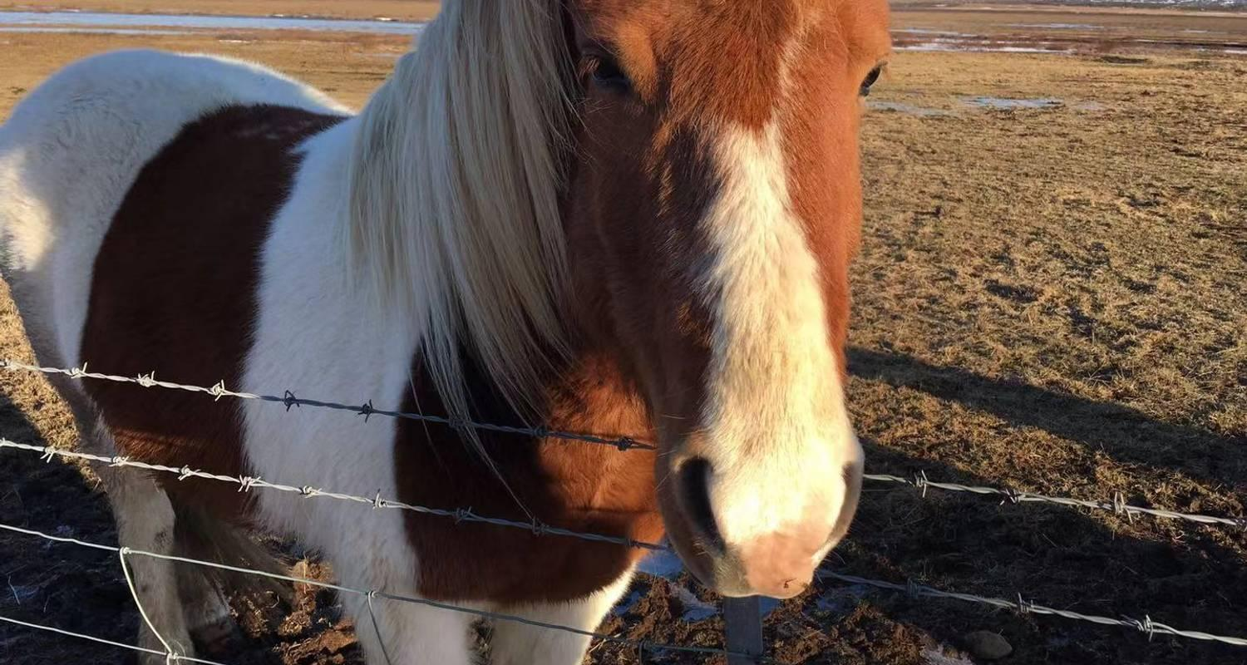

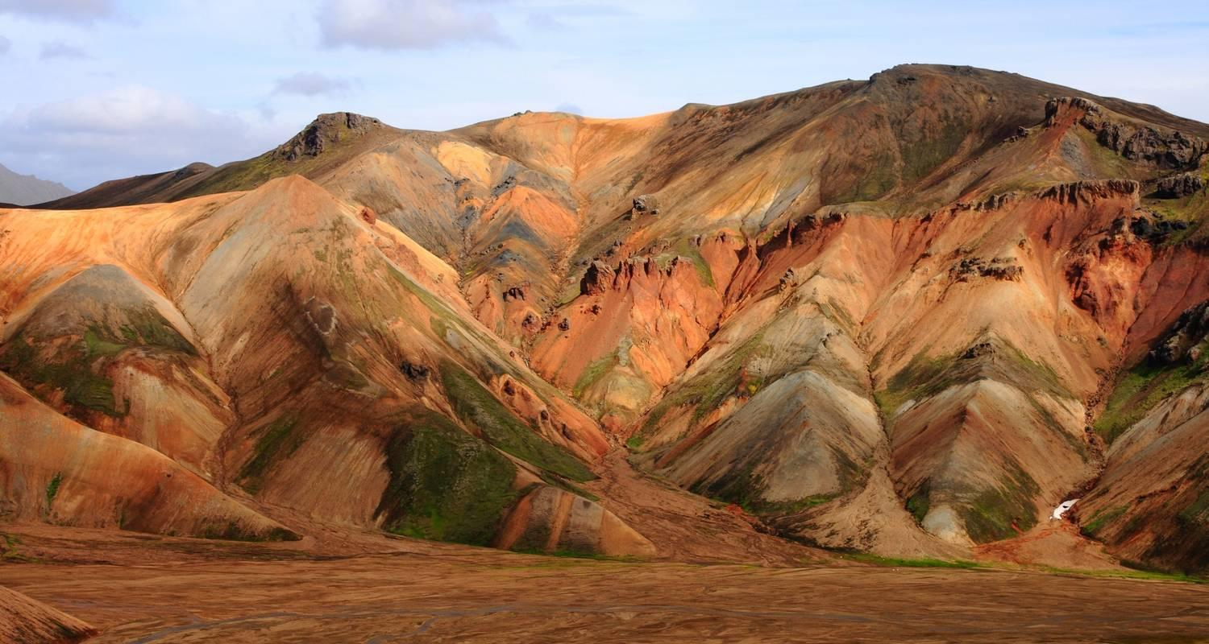

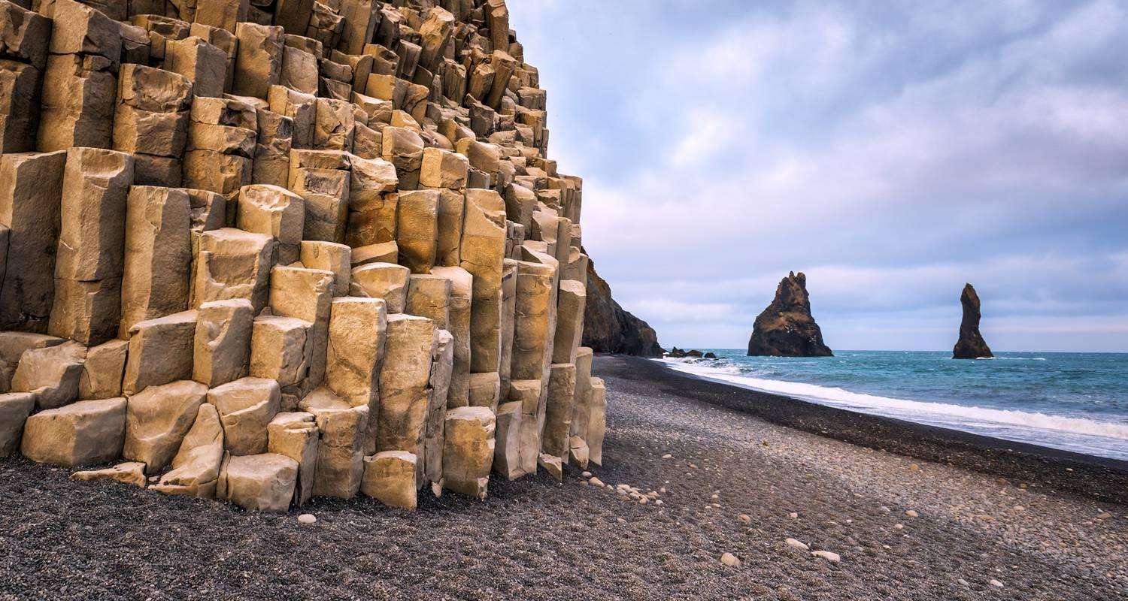

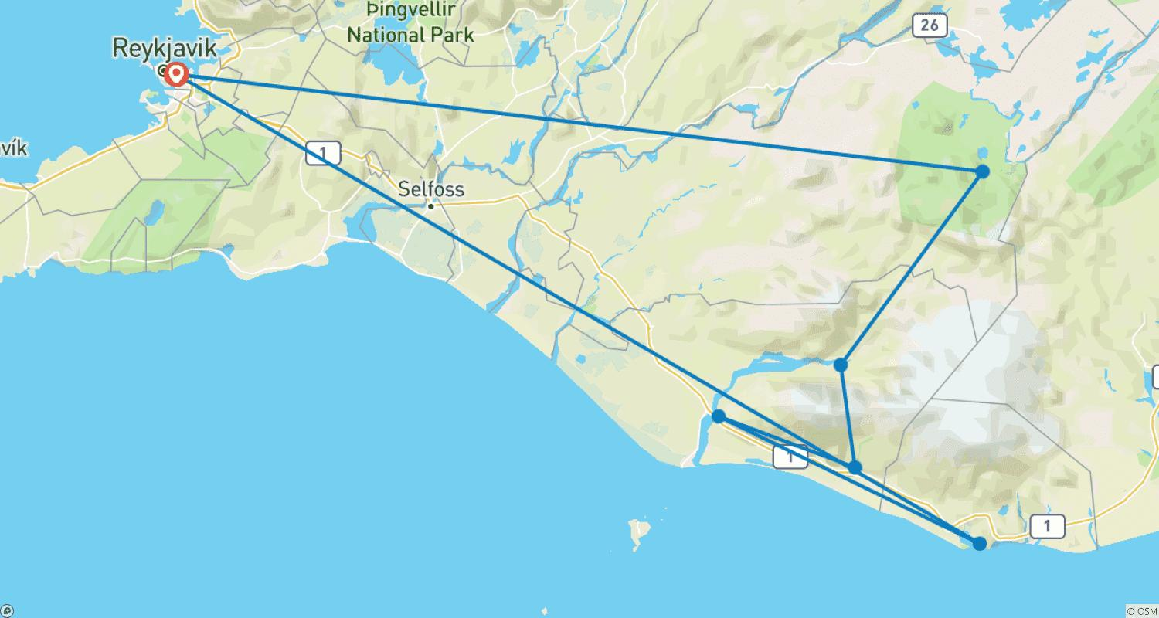

Tour ID: 260765  
Tour Name: Iceland, Jan Mayen, Spitsbergen – Island Hopping in and around the Arctic (Northbound)

Tour destinations: ['Reykjavik', 'Grundarfjordur', 'Isafjordur', 'Akureyri', 'Godafoss', 'Husavik', 'Jan Mayen Island', 'Spitsbergen', 'Longyearbyen']

Tour destinations images:

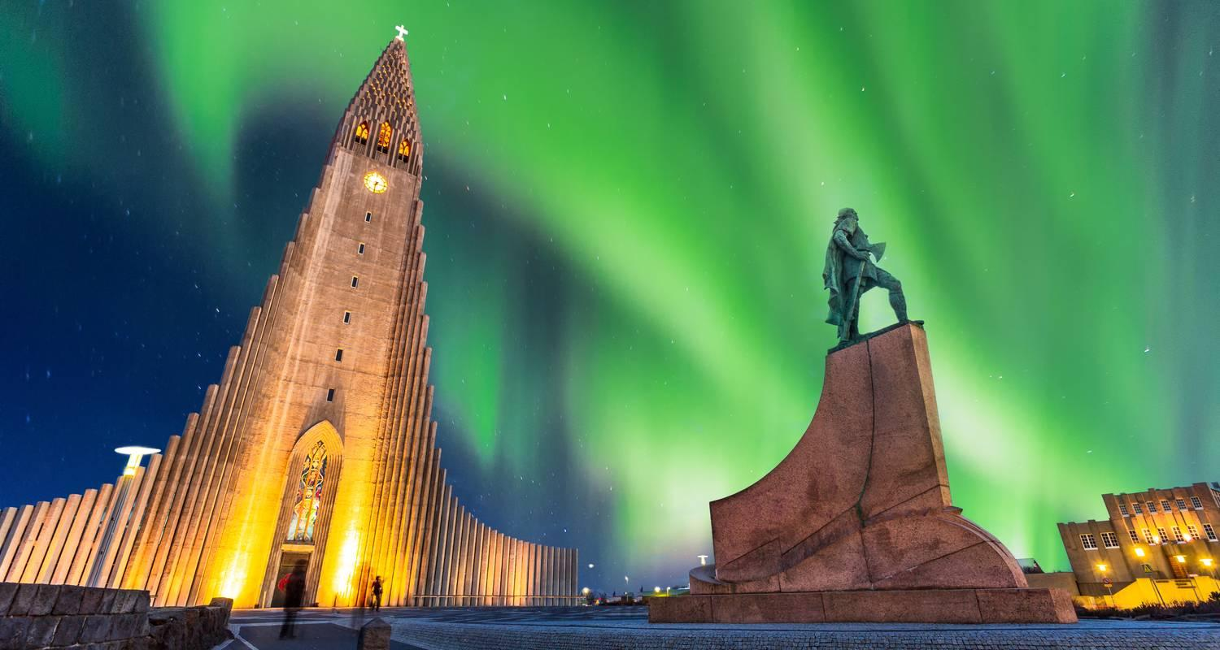

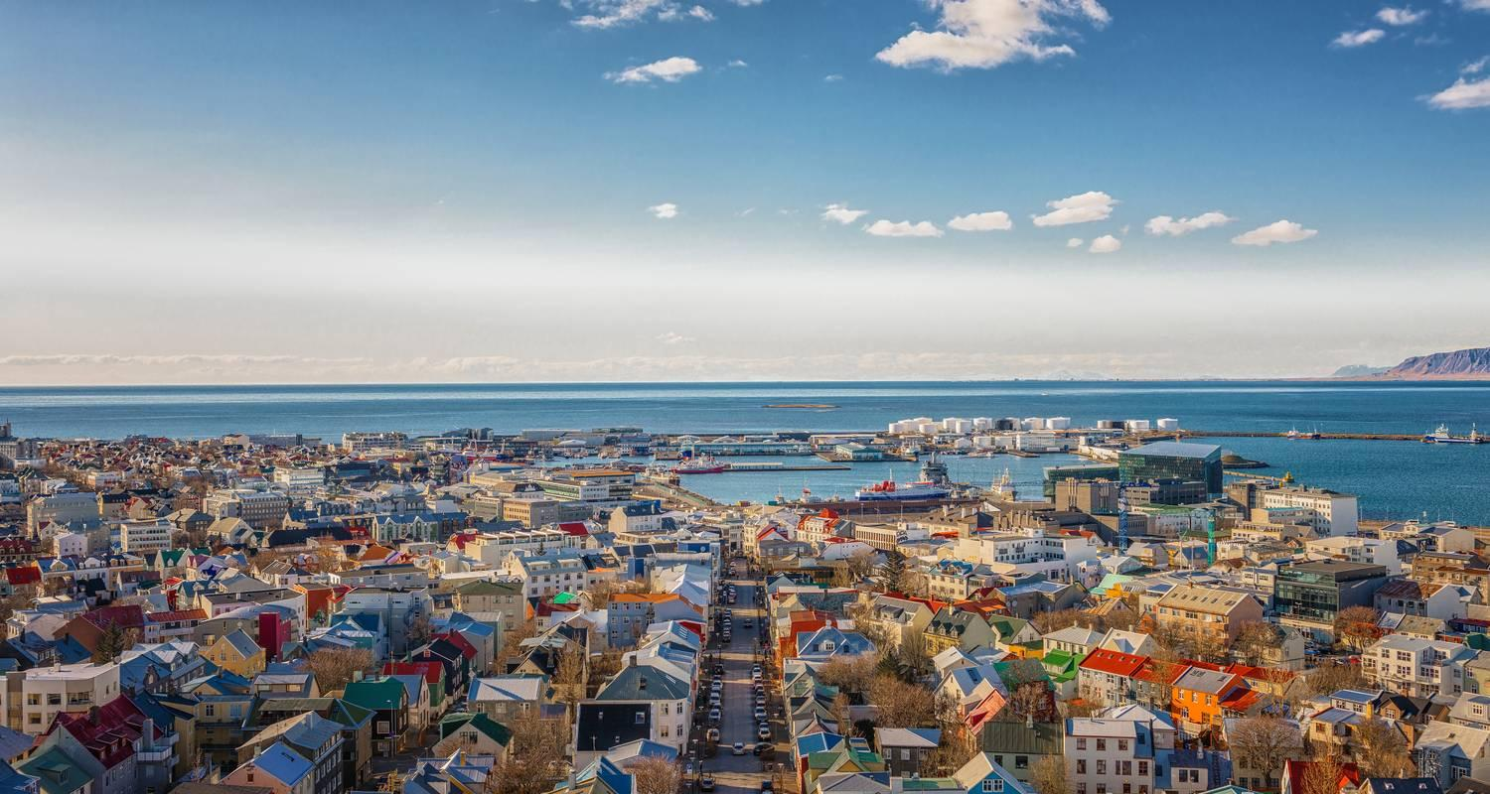

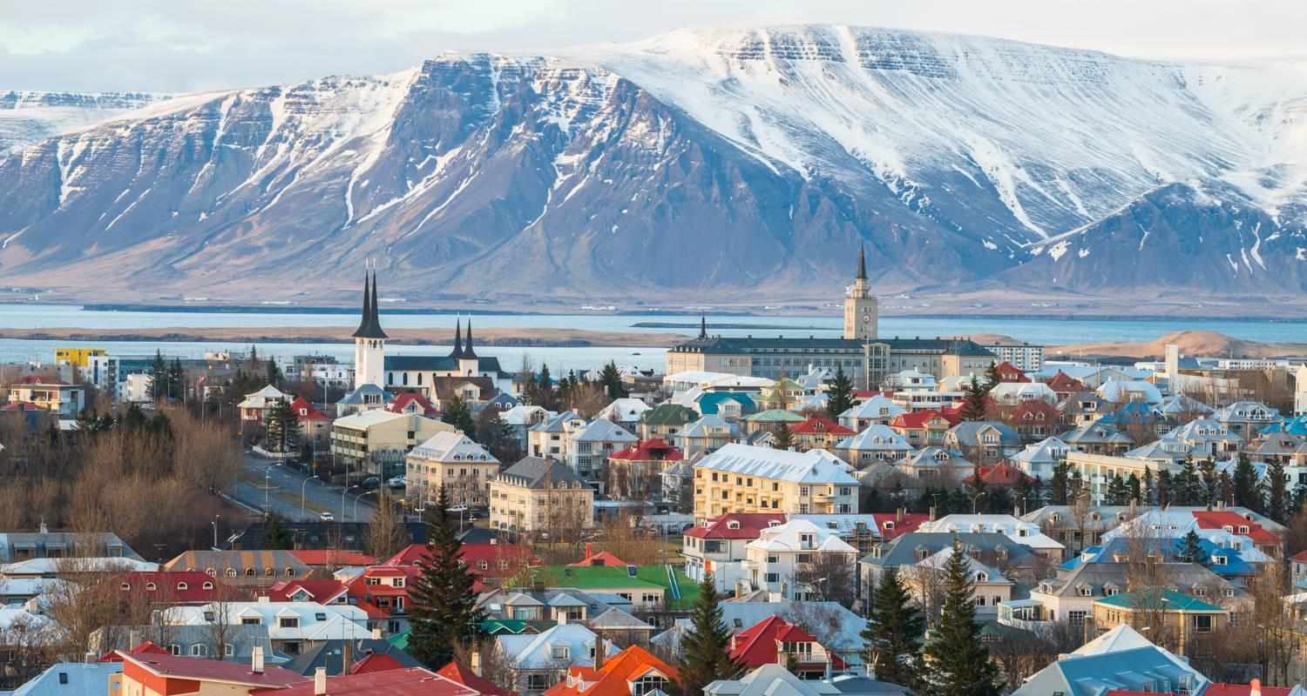

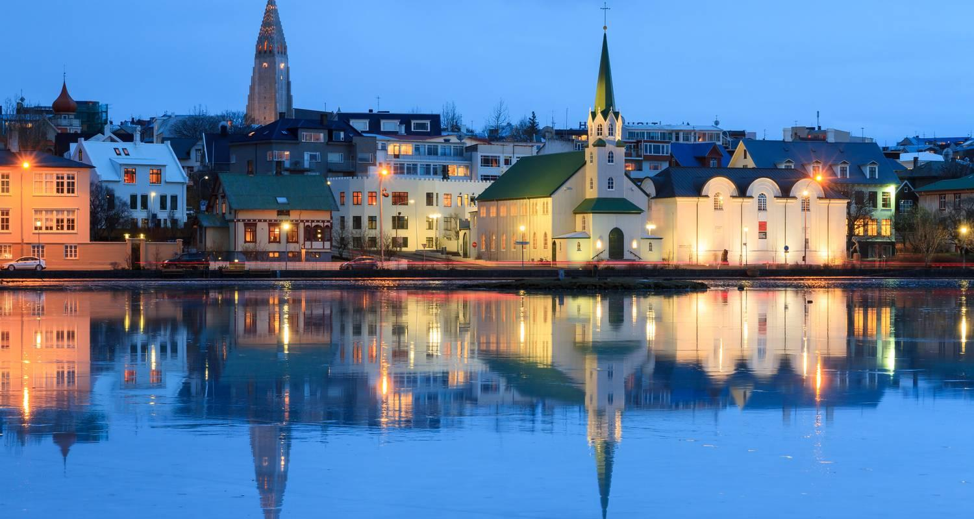

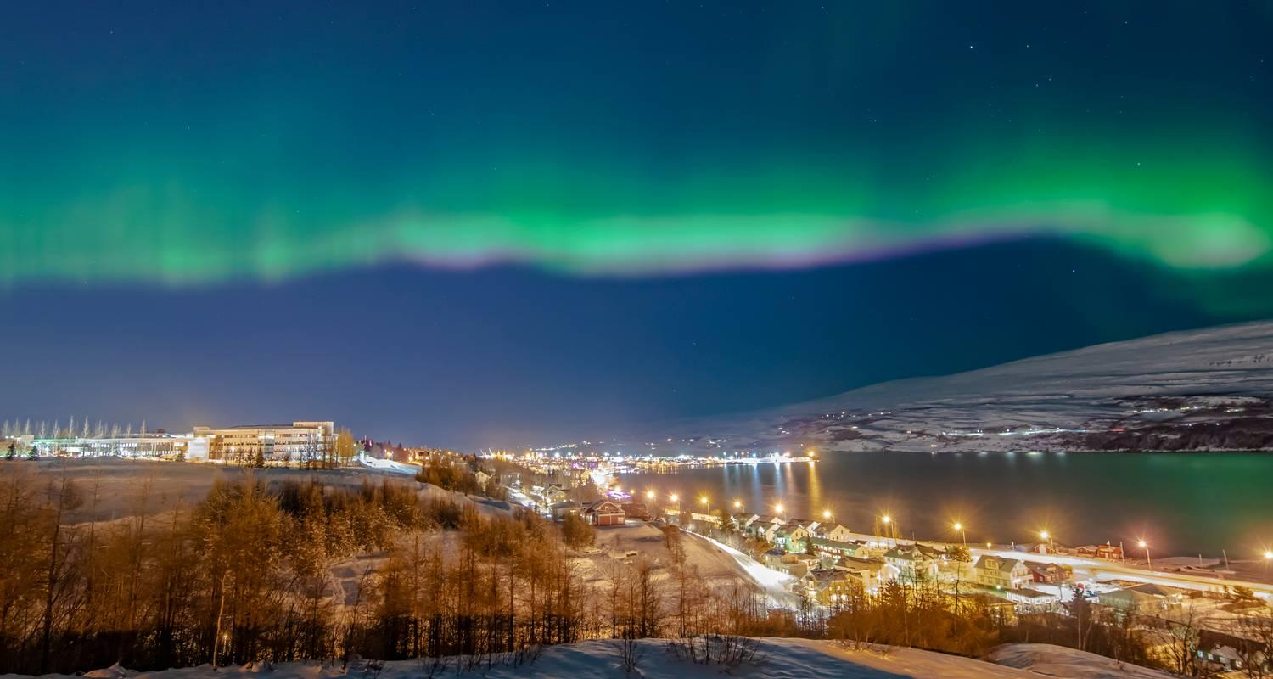

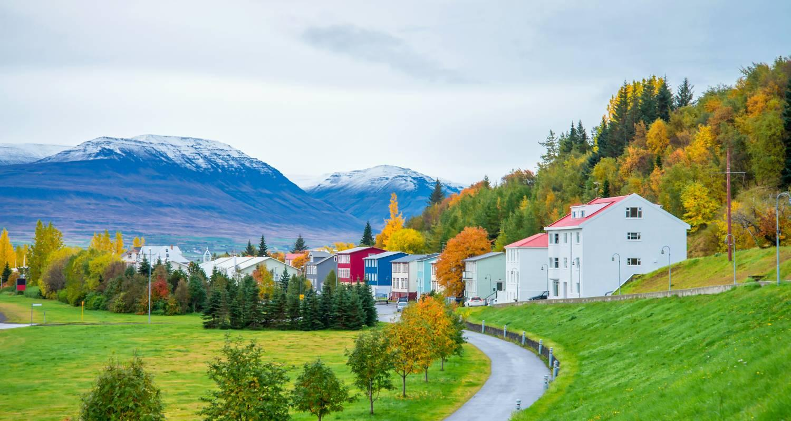

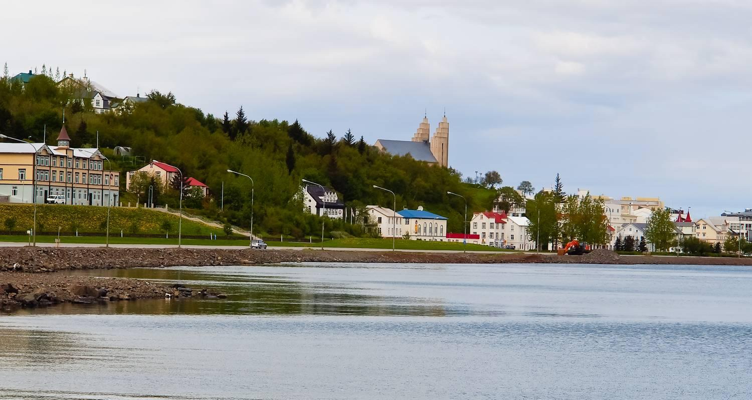

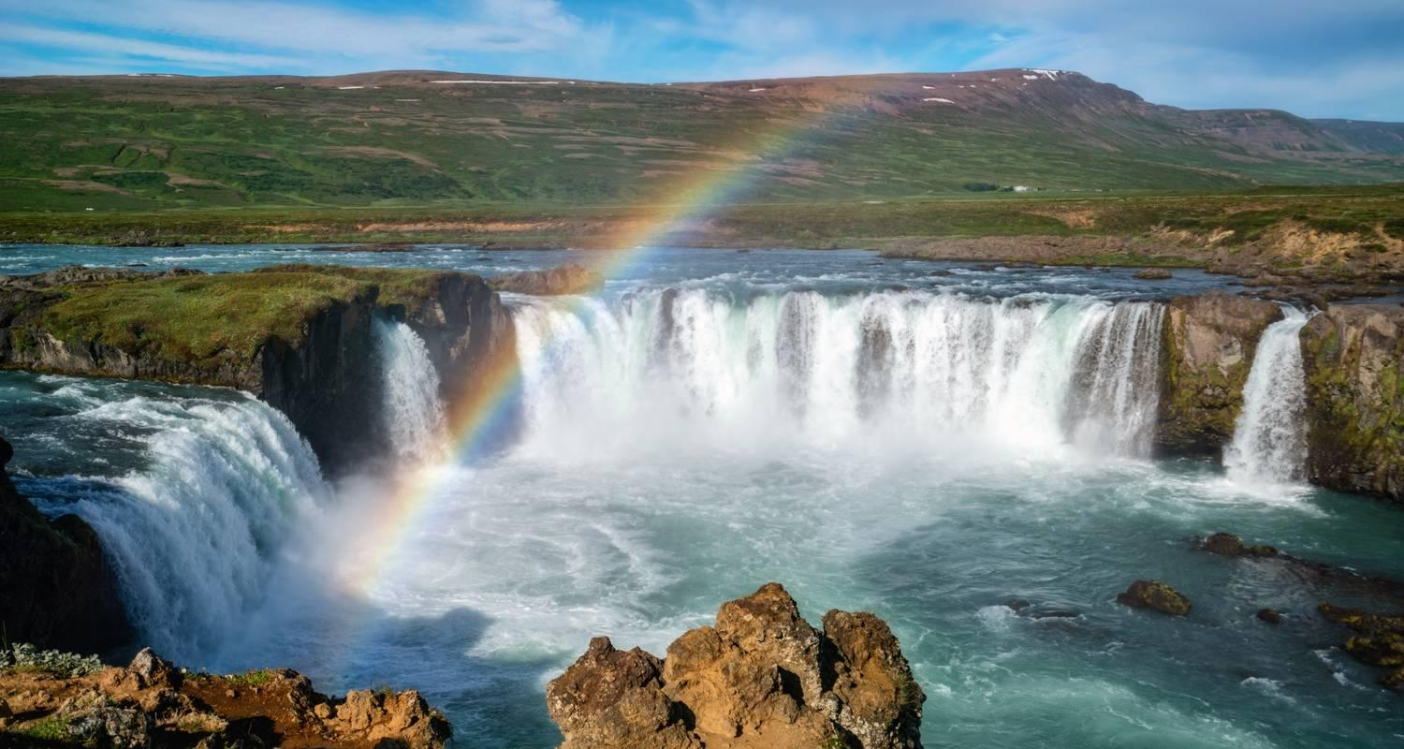

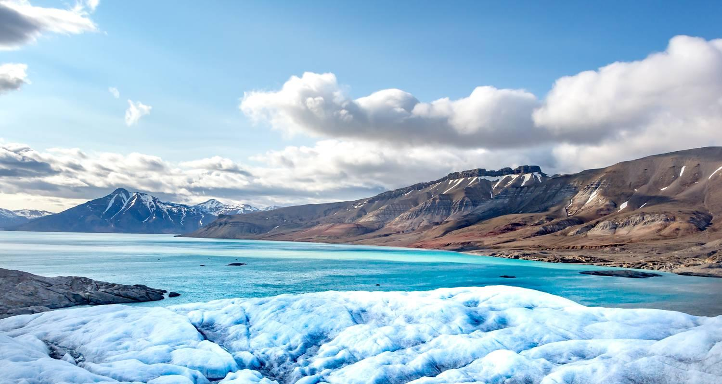

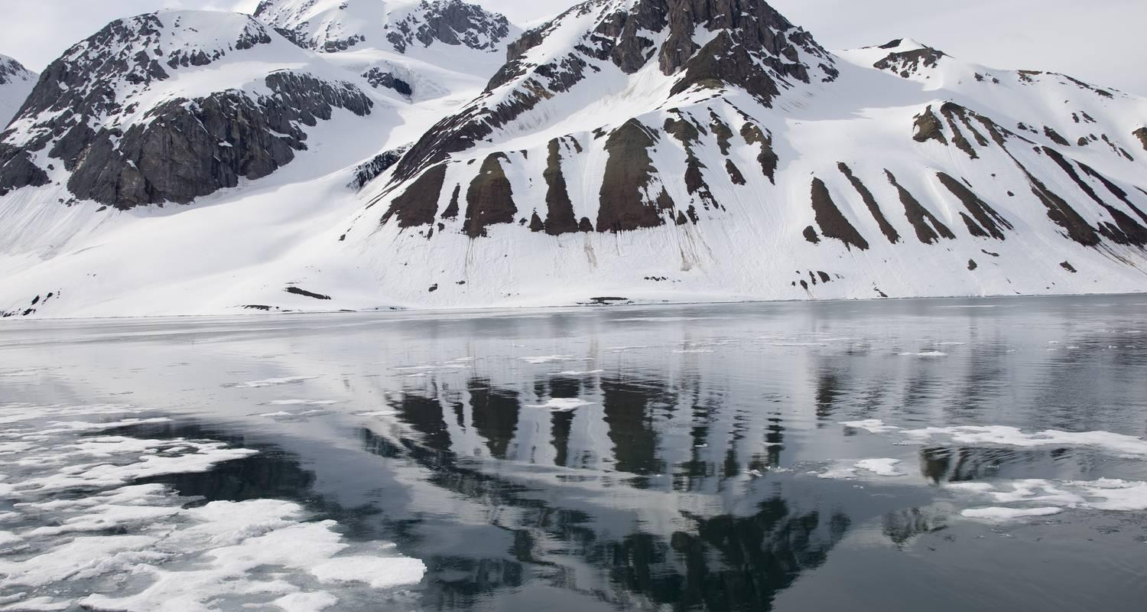

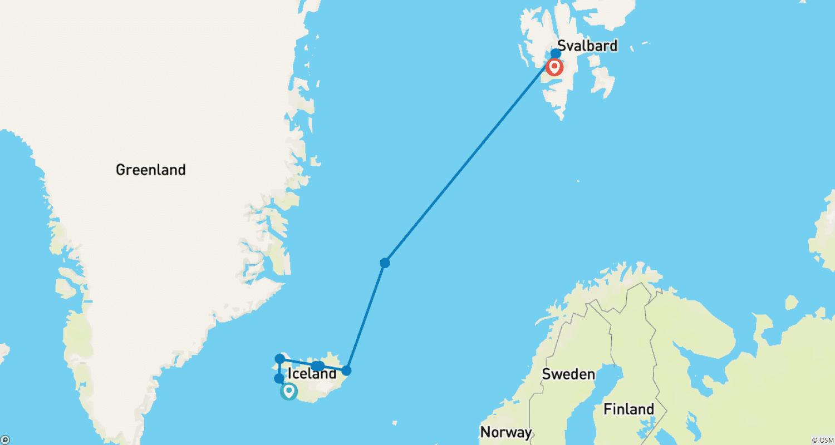

Tour ID: 261033  
Tour Name: 7 Days Gracious Southwest Iceland

Tour destinations: ['Reykjavik', 'Kerid Volcano', 'Gullfoss', 'Geysir', 'Thingvellir National Park', 'Efstidalur', 'Vik', 'Reynisfjara', 'Skogafoss', 'Gunnuhver', 'Reykjanesviti', 'Blue Lagoon']

Tour destinations images:

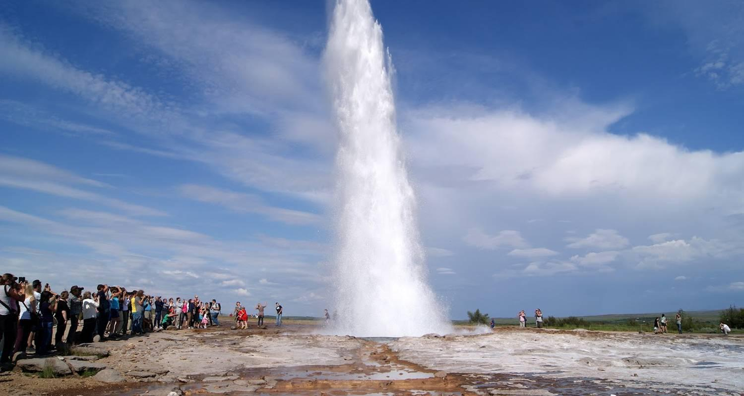

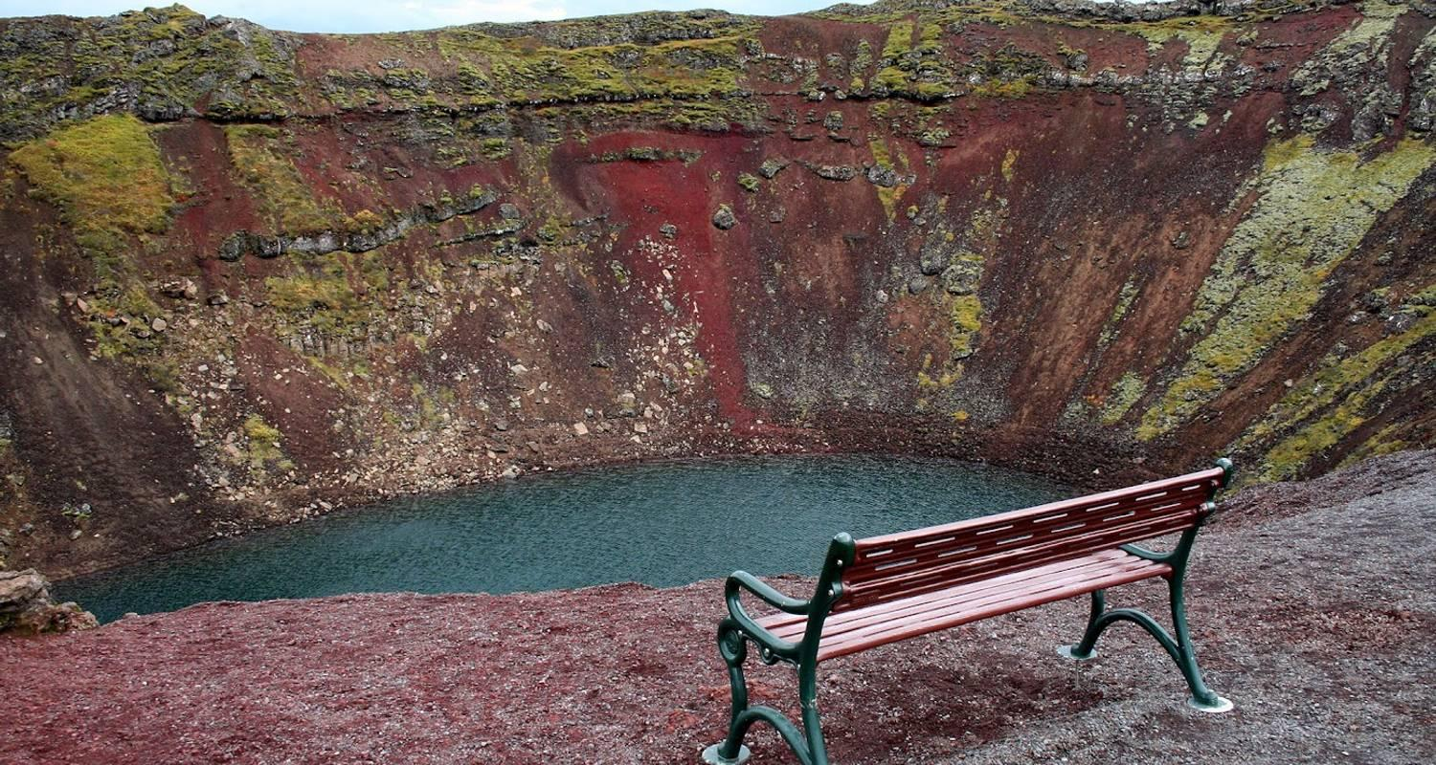





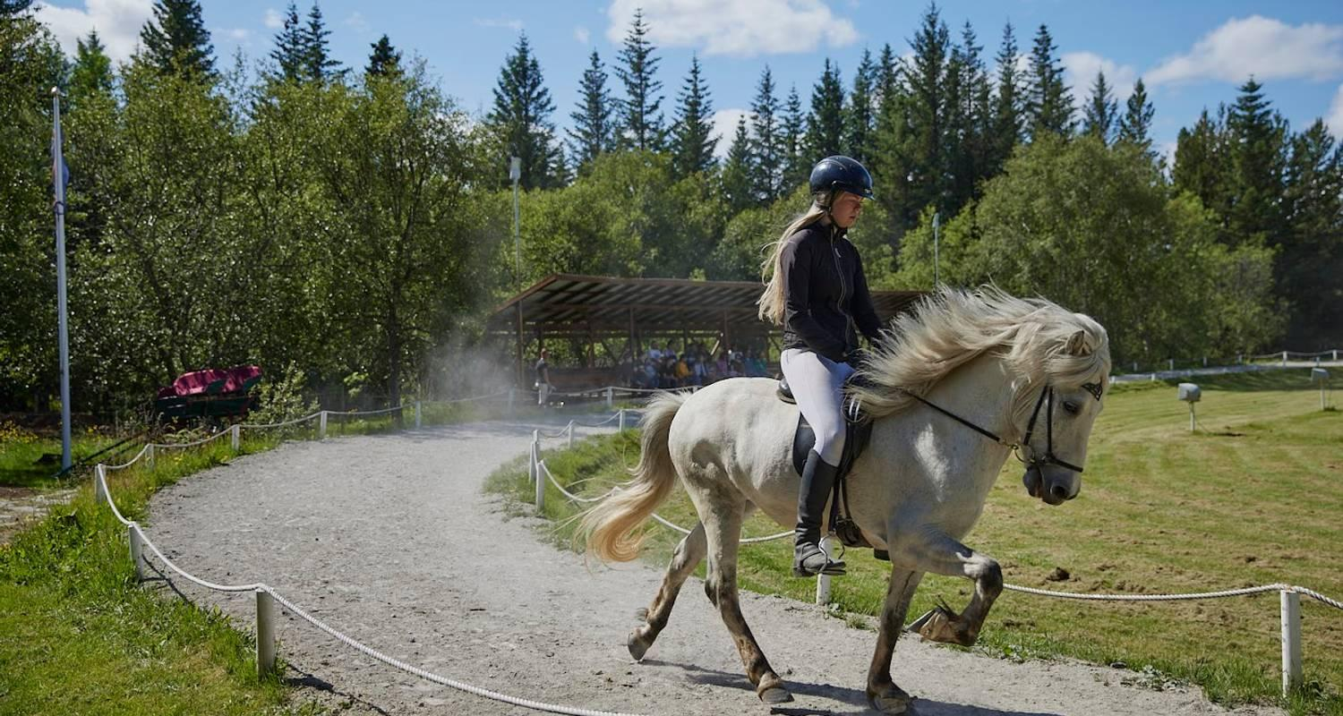

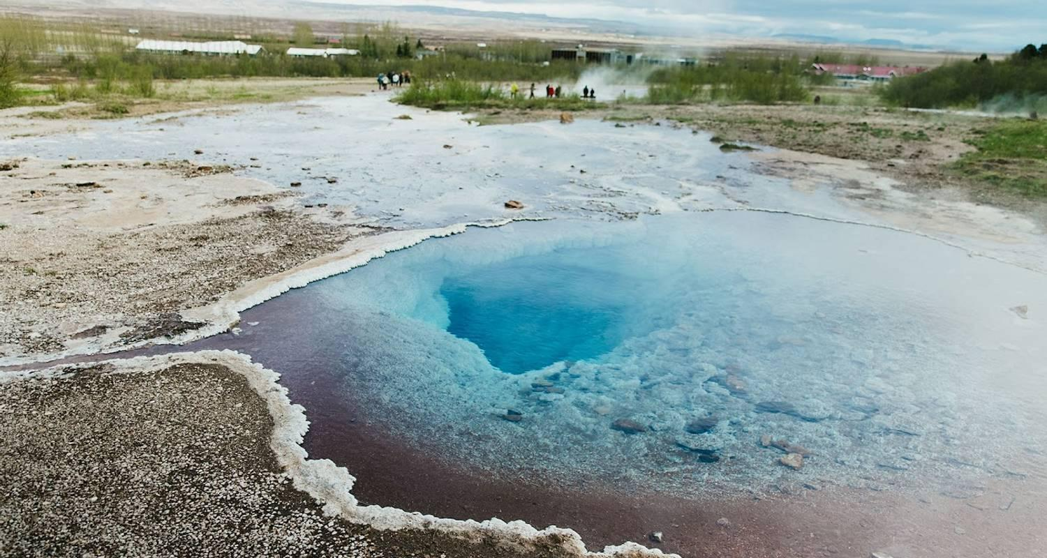

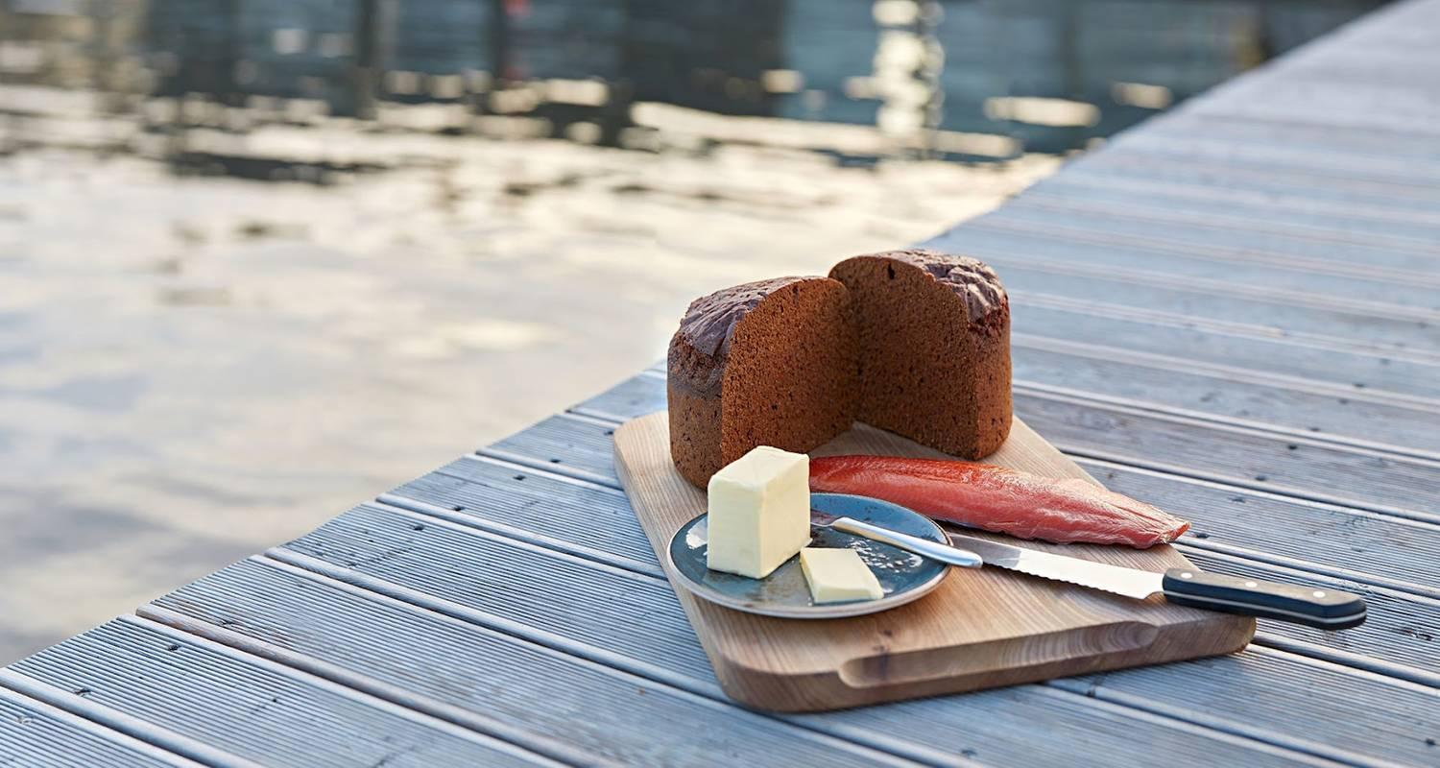

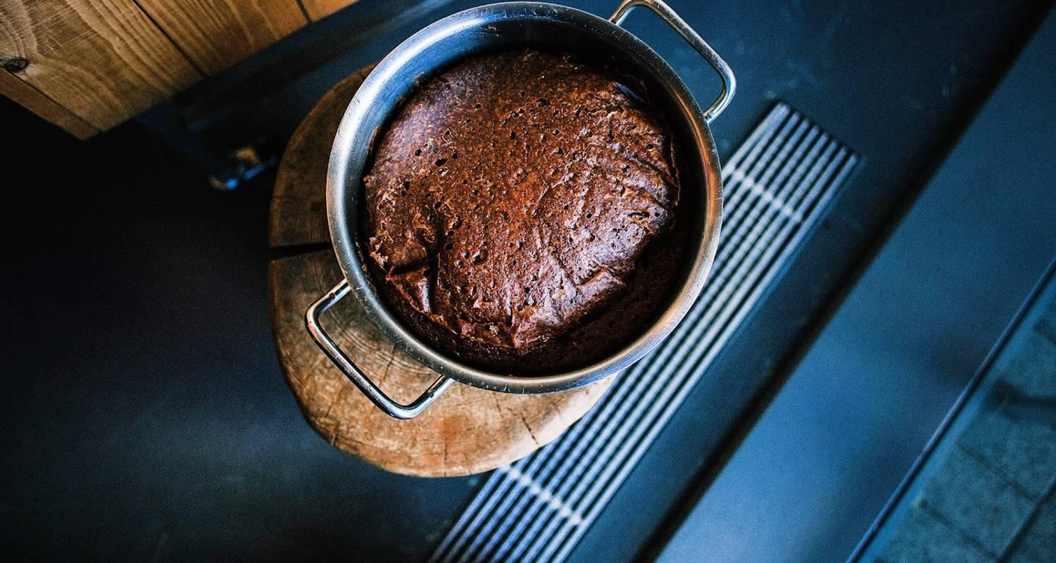

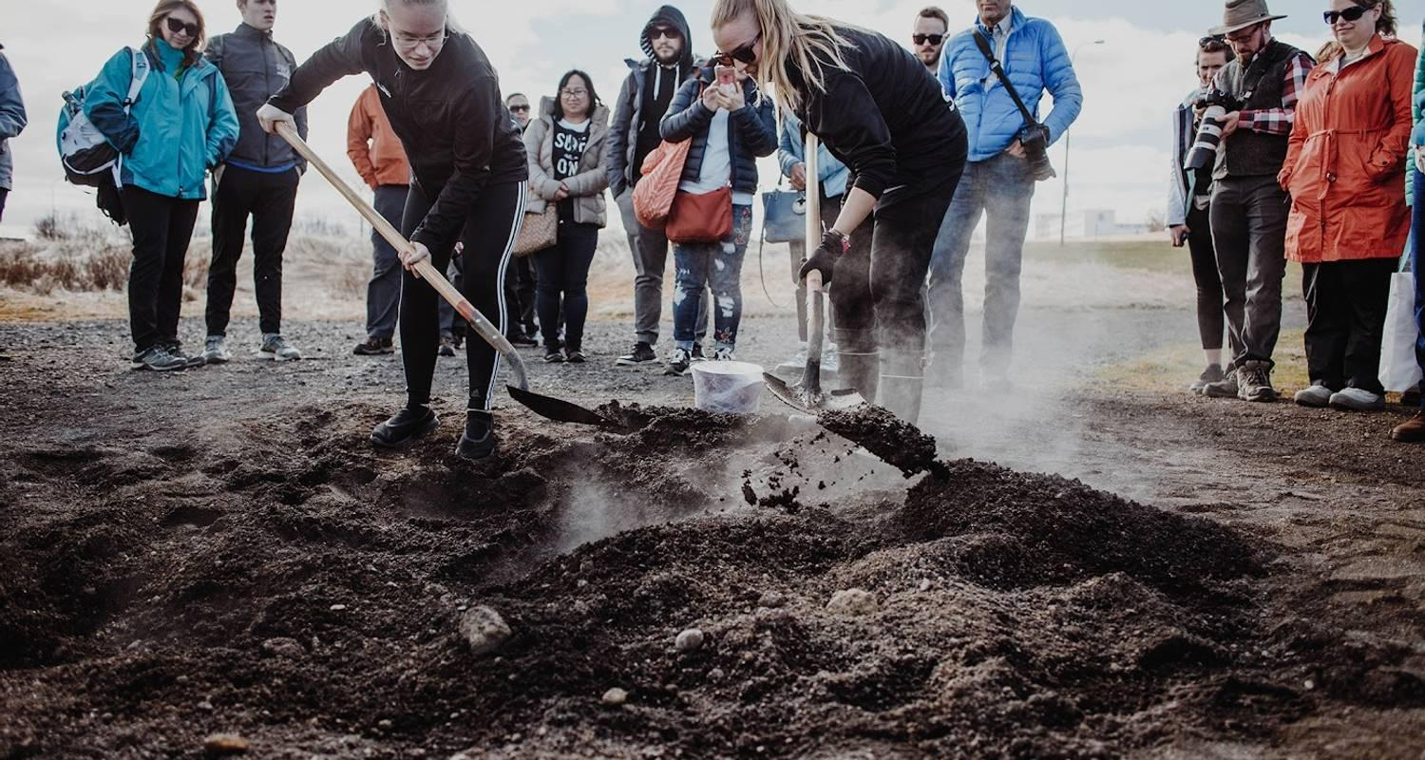

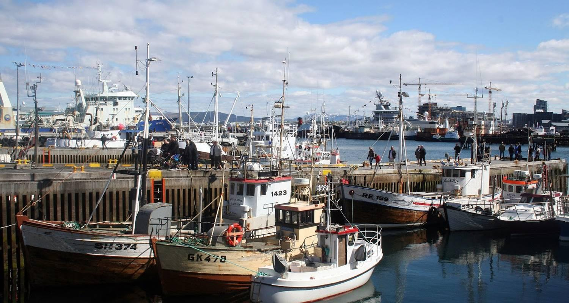

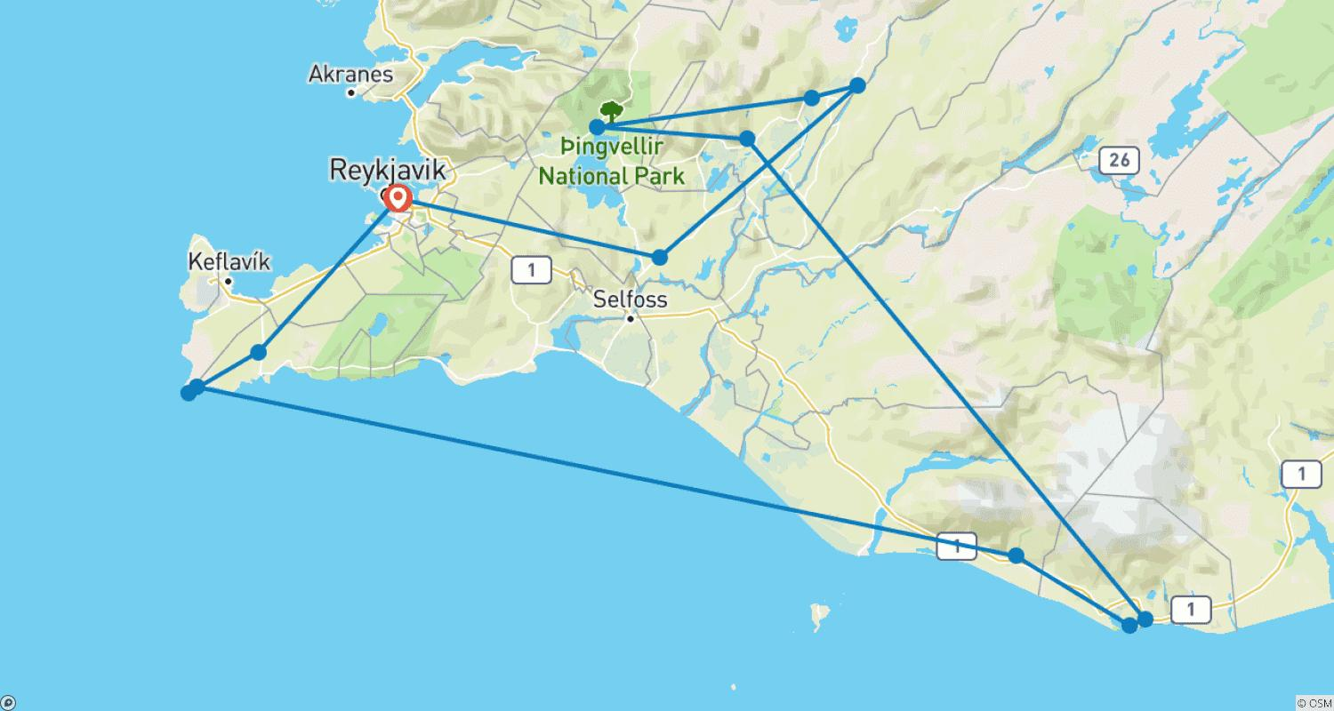

Tour ID: 261044  
Tour Name: Iceland Fire and Ice (Winter, 6 Days)

Tour destinations: ['Reykjavik', 'Thingvellir National Park', 'Efstidalur', 'Geysir', 'Skaftafell', 'Reynisfjara', 'Vik', 'Blue Lagoon']

Tour destinations images:



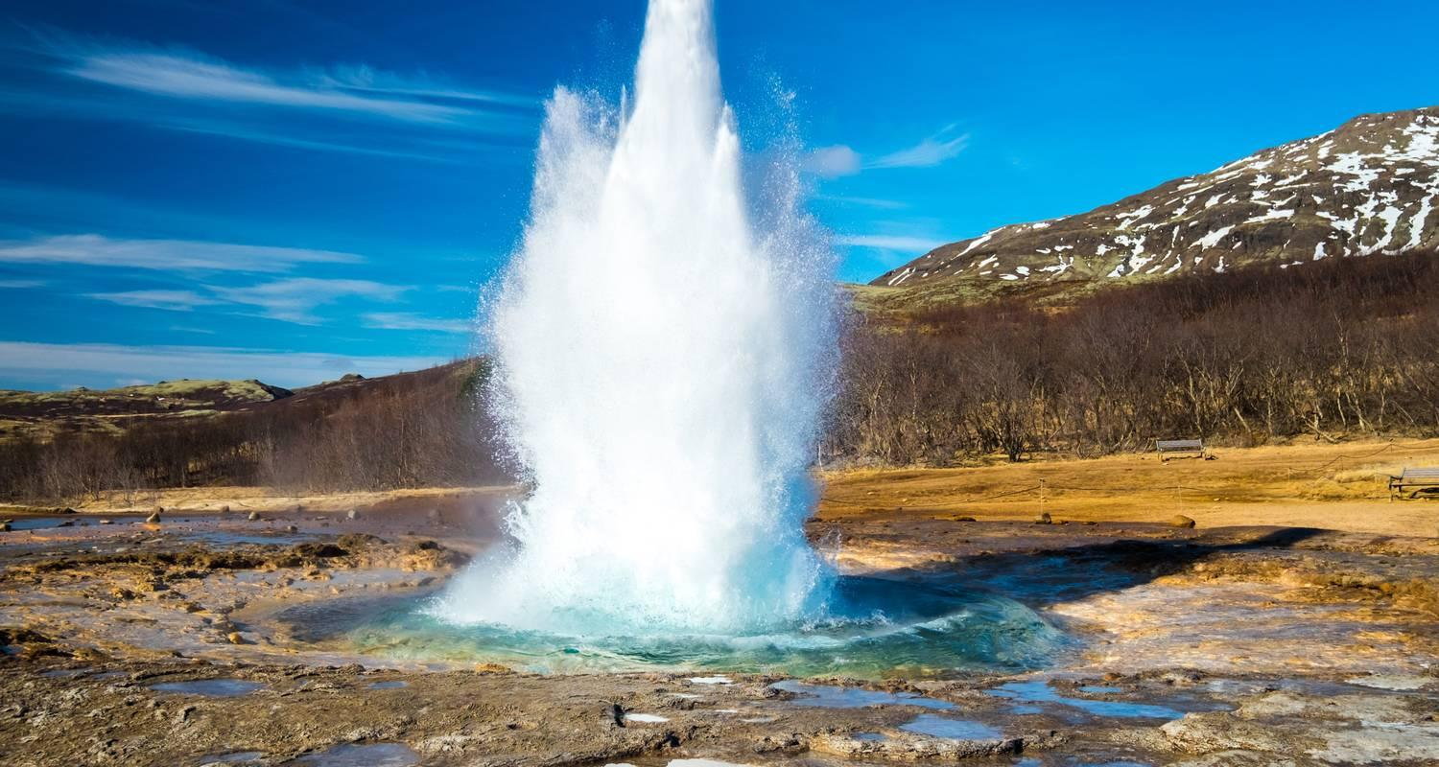

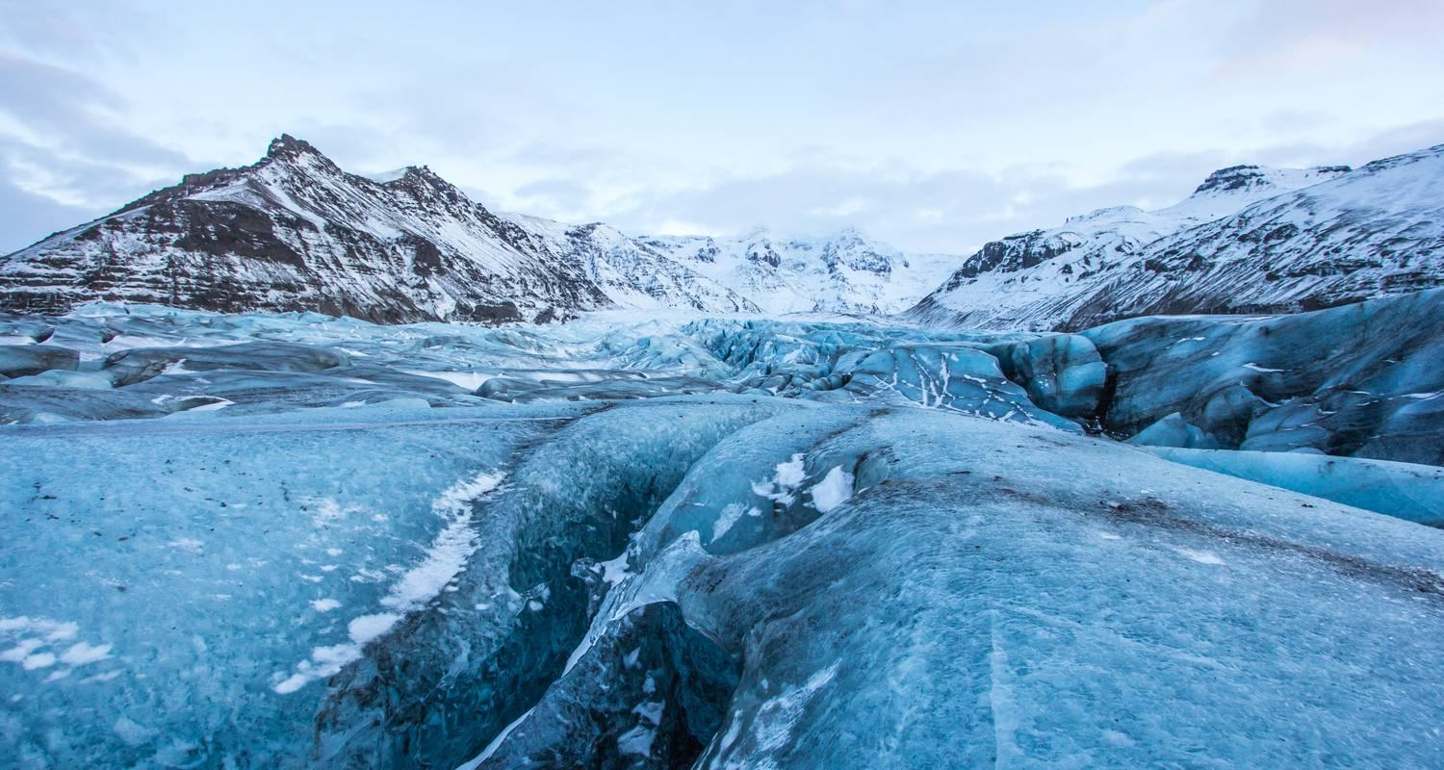

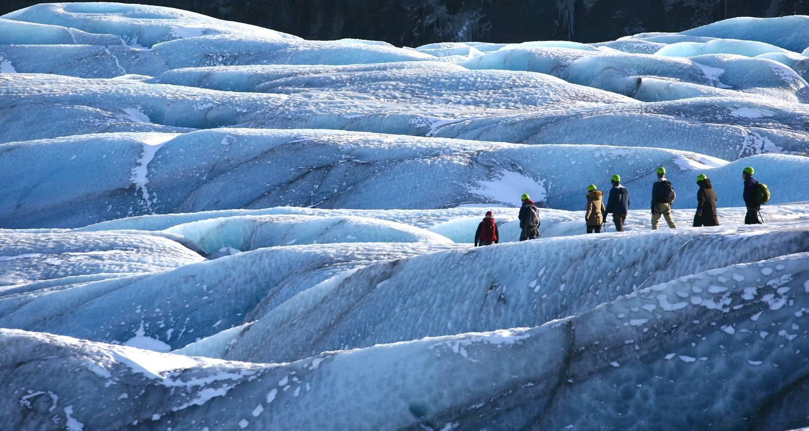

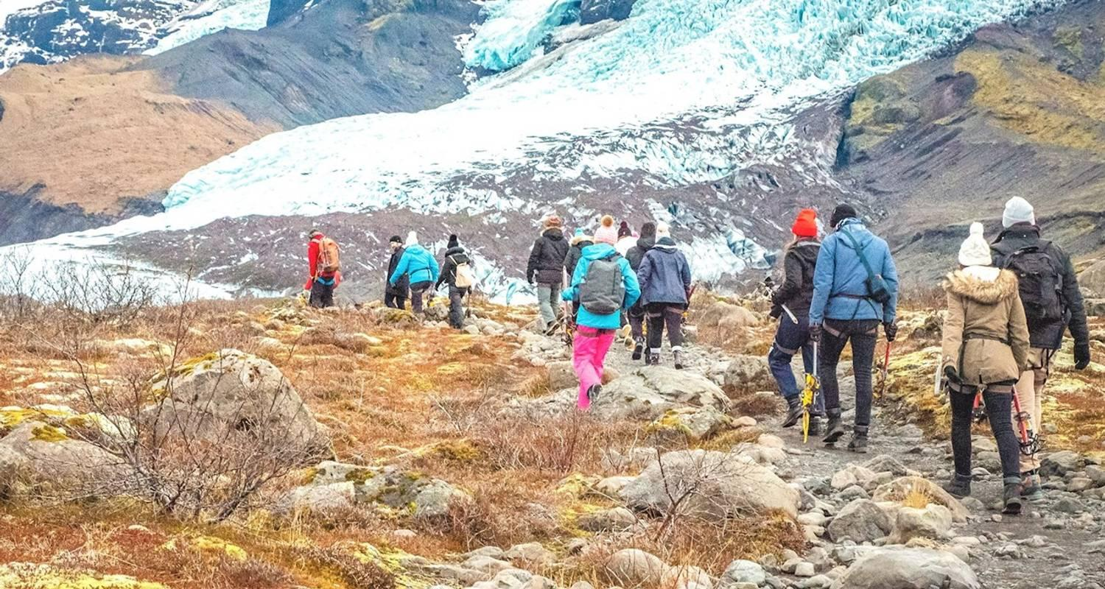

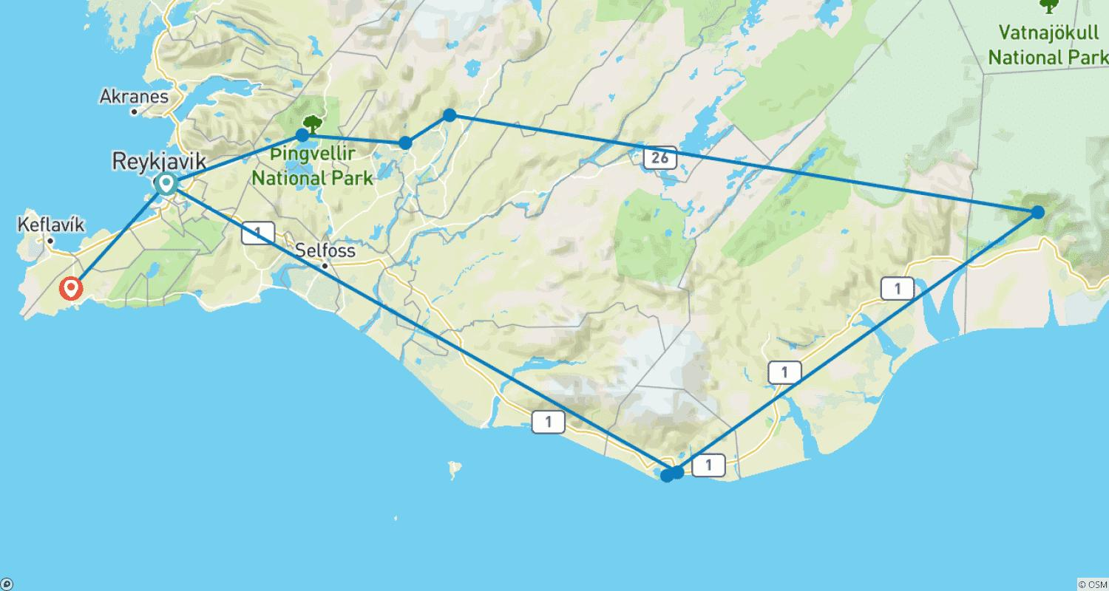

Tour ID: 261045  
Tour Name: Iceland Fire and Ice (Summer, 6 Days)

Tour destinations: ['Reykjavik', 'Thingvellir National Park', 'Efstidalur', 'Geysir', 'Skaftafell', 'Reynisfjara', 'Vik', 'Blue Lagoon']

Tour destinations images:



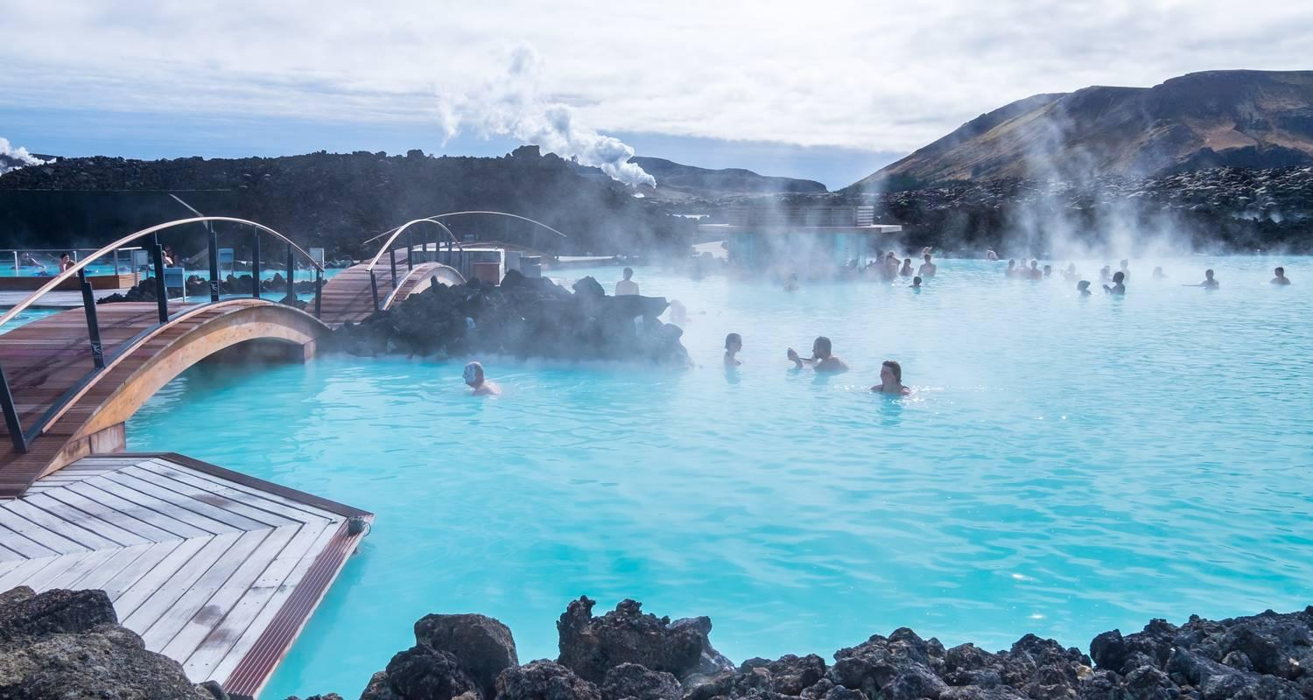

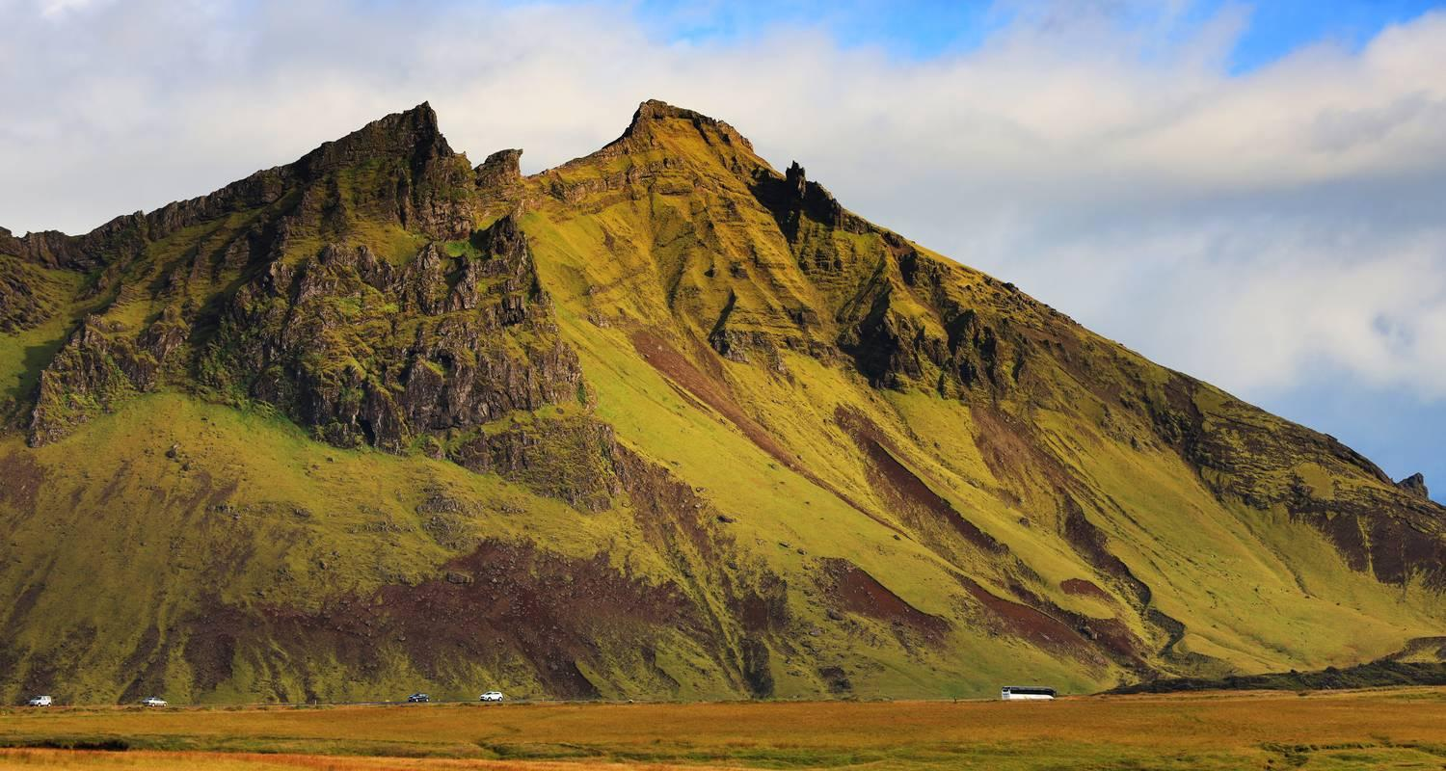

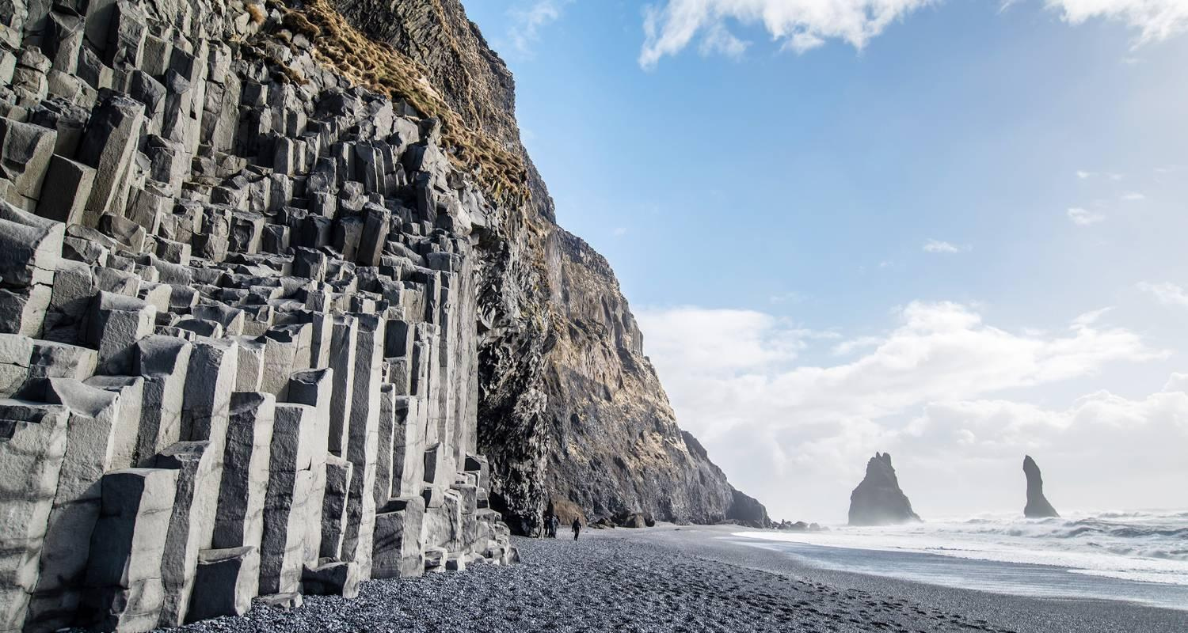

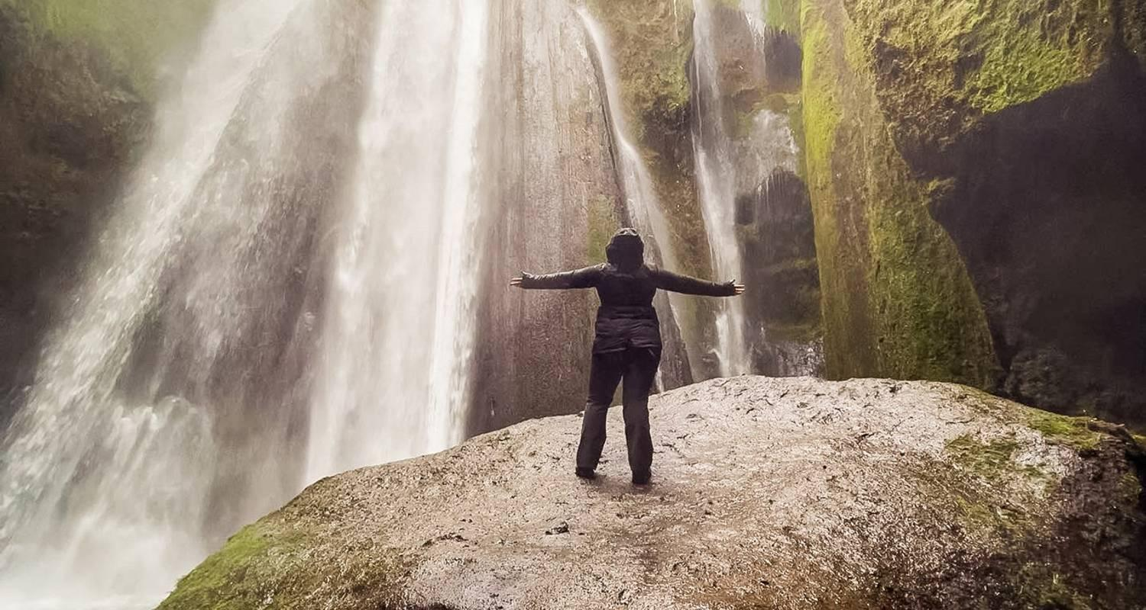



Tour ID: 261248  
Tour Name: Serene Greenland - To the World's Largest National Park

Tour destinations: ['Reykjavik']

Tour destinations images:

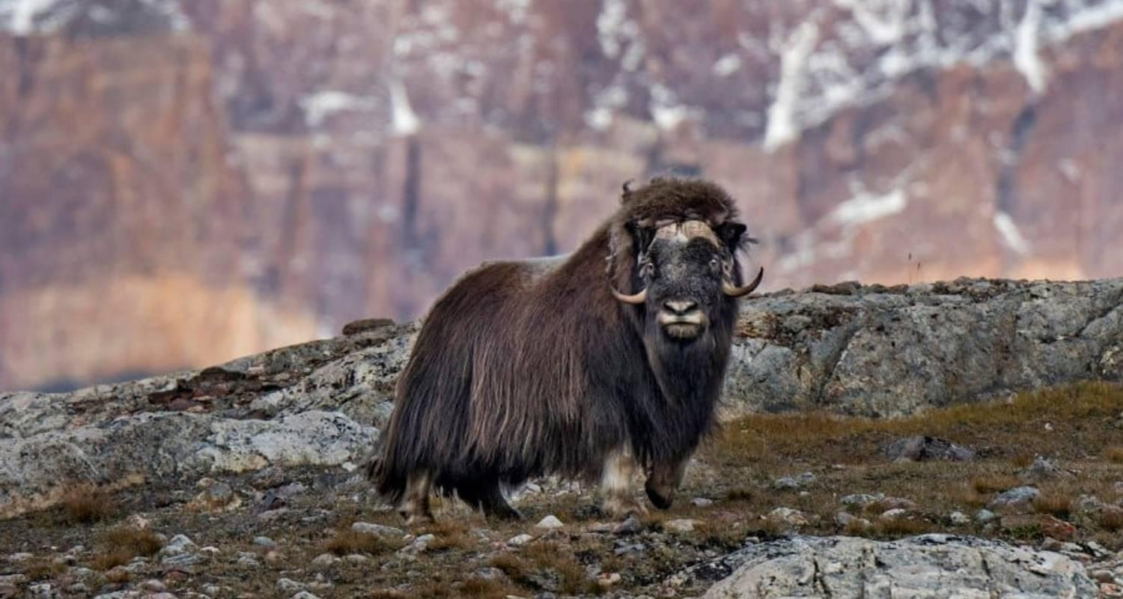

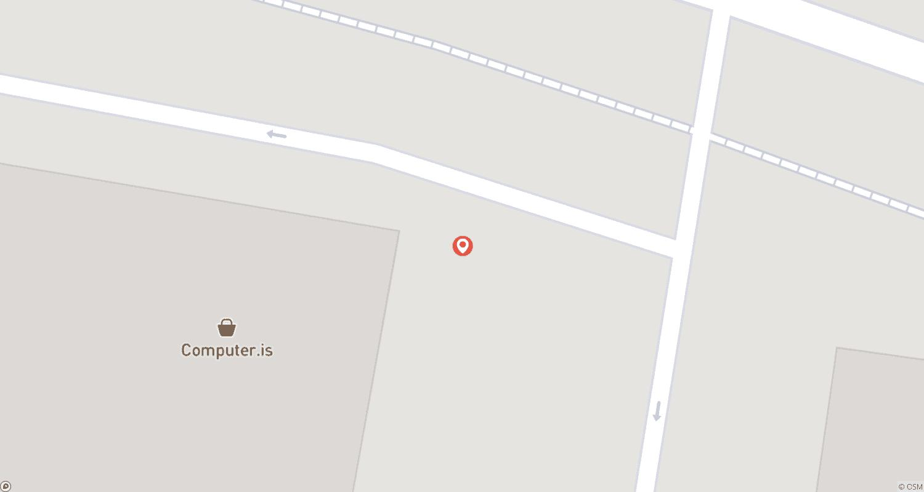

Tour ID: 261249  
Tour Name: Arctic Islands Discovery – Svalbard, Jan Mayen, Greenland and Iceland

Tour destinations: ['Oslo', 'Longyearbyen', 'Spitsbergen', 'Nordvest-Spitsbergen National Park', 'Jan Mayen Island', 'Scoresby Sound', 'Grundarfjordur', 'Reykjavik']

Tour destinations images:

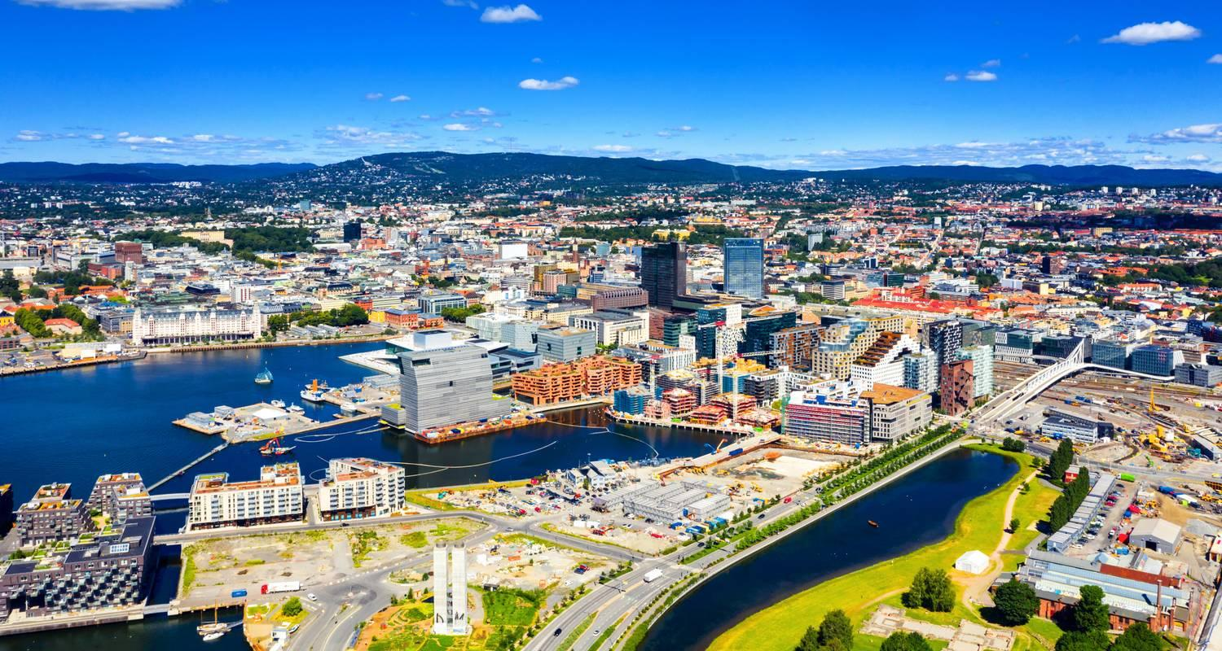

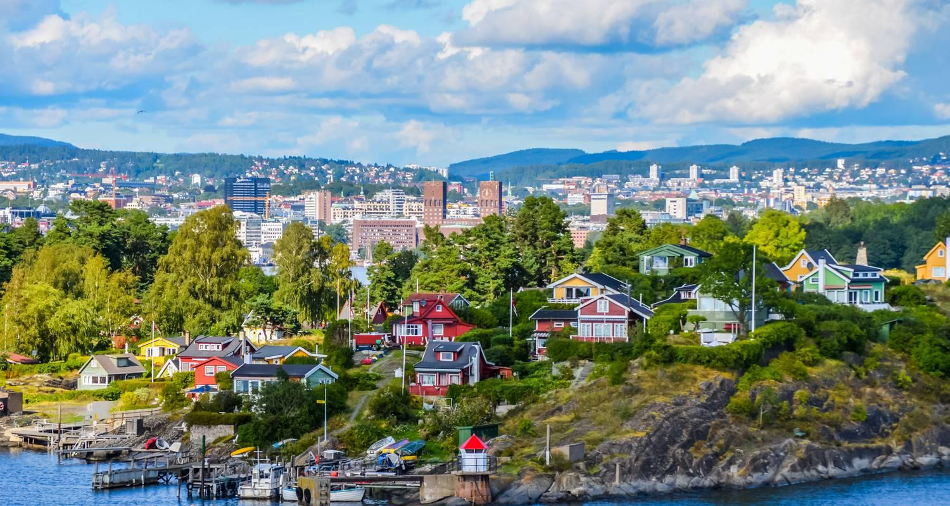

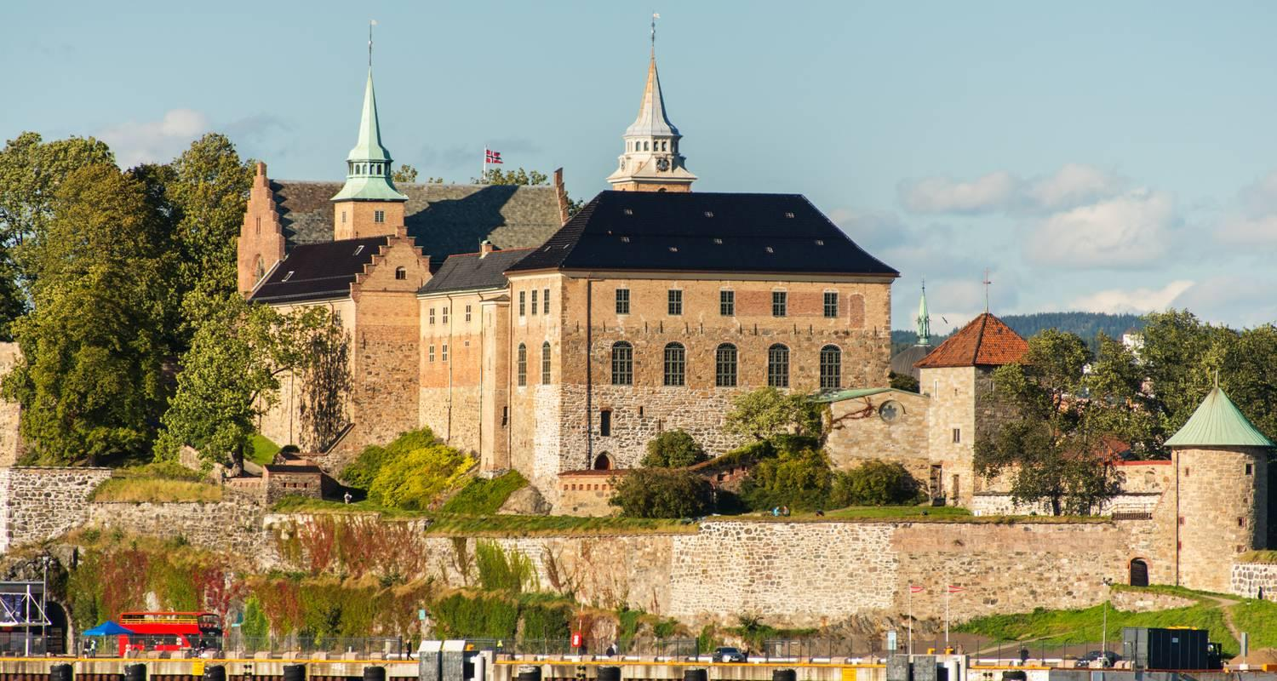

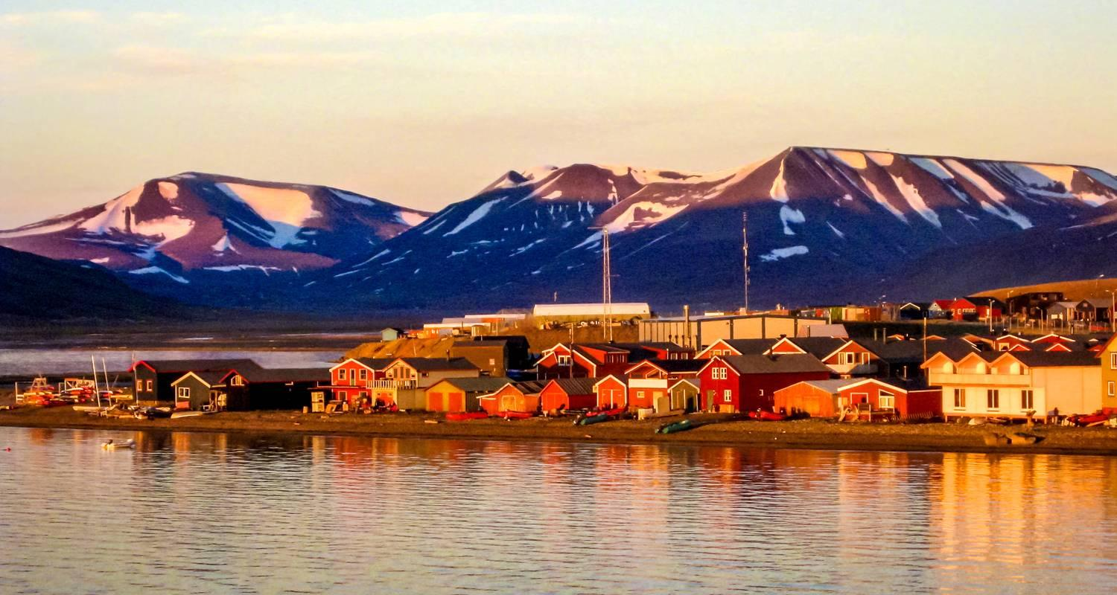

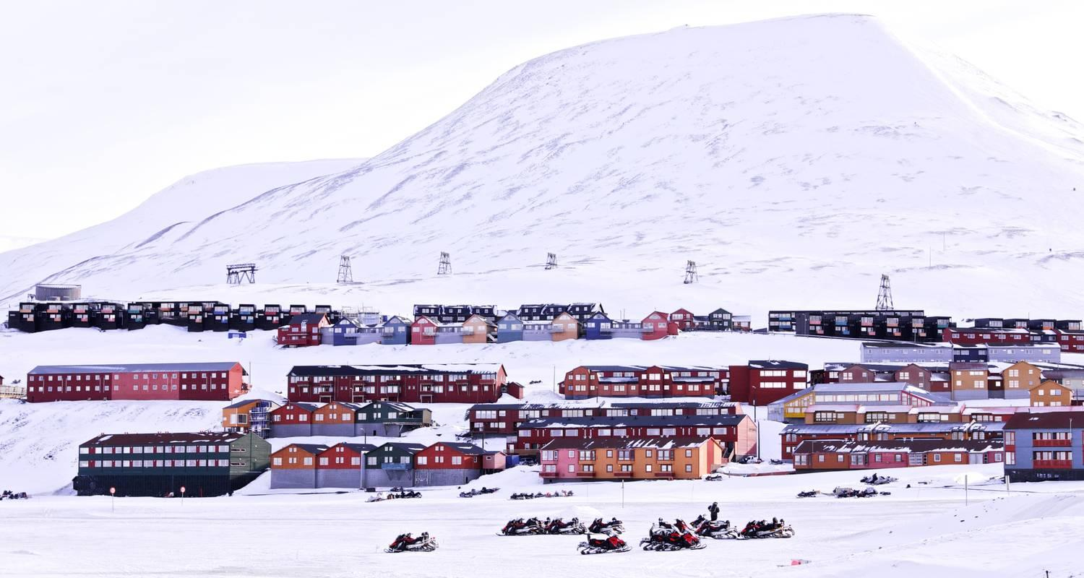





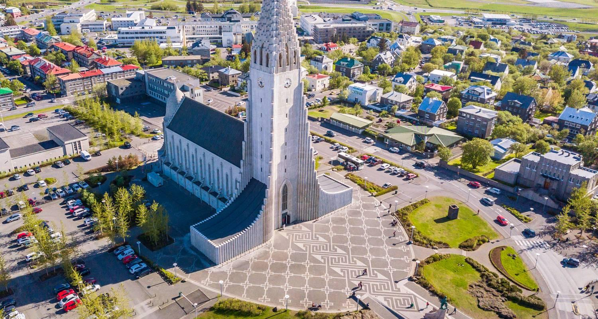





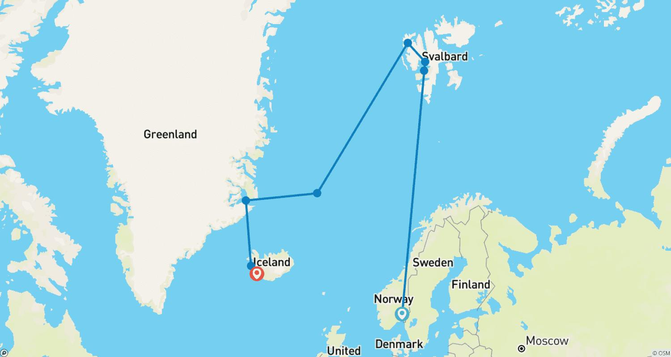

Tour ID: 261250  
Tour Name: The Ultimate Fjord and National Park Expedition

Tour destinations: ['Reykjavik']

Tour destinations images:

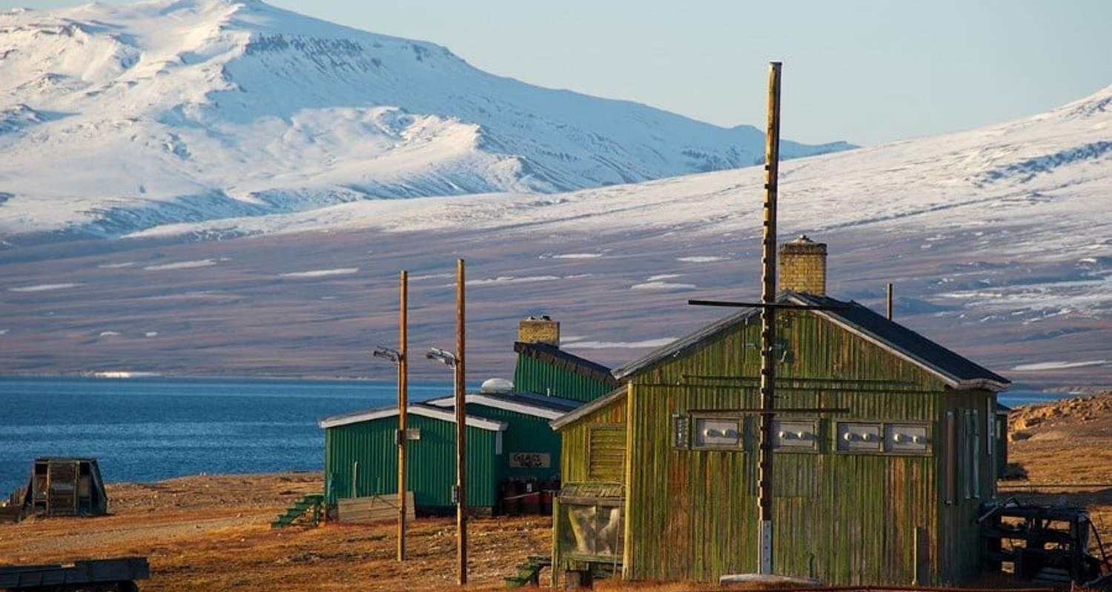



Tour ID: 261251  
Tour Name: Serene Greenland - Exploring the Largest Fjord System on Earth

Tour destinations: ['Reykjavik', 'Scoresby Sound', 'Ittoqqortoormiit']

Tour destinations images:











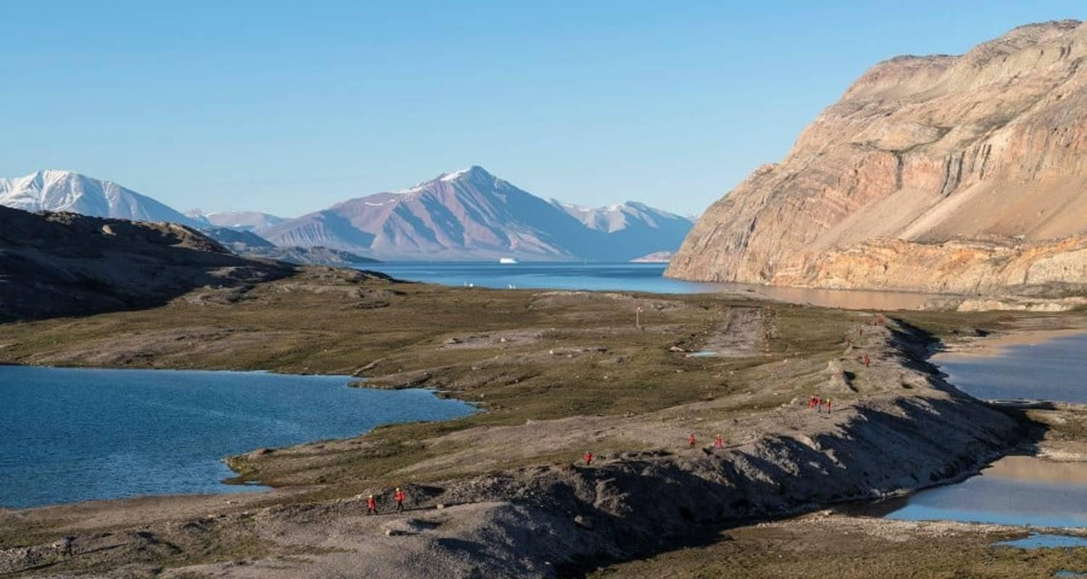

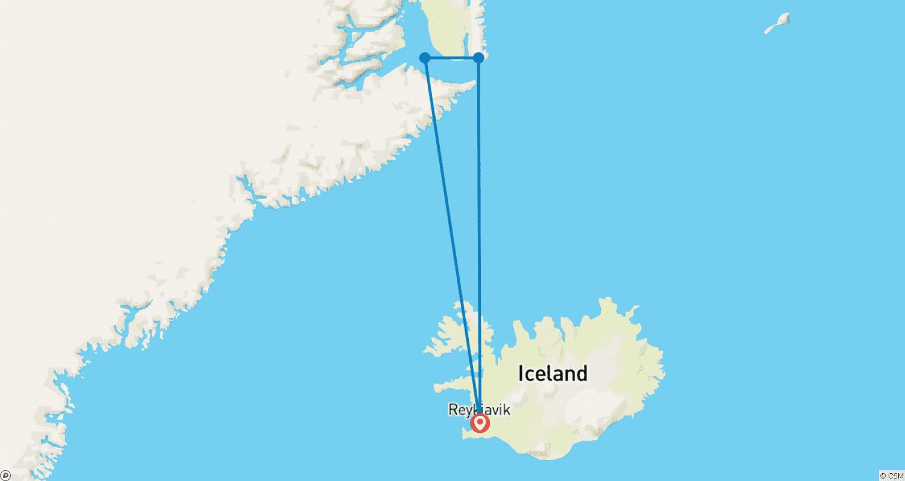

Tour ID: 261295  
Tour Name: South Greenland expedition – In the wake of Erik the Red

Tour destinations: ['Reykjavik', 'Qaqortoq', 'Ivittuut', 'Nuuk']

Tour destinations images:







